FIFO MENU

|  |  |  |  |  |
| --- | --- | --- | --- | --- |
| id | MenuName | ShortName | Node | Menu |
| 1 | Item Master | IM | 1 | Masters |
| 2 | Vendor Master | VM | 1 | Masters |
| 3 | JobWork Master | JWM | 1 | Masters |
| 4 | Section Master | SM | 1 | Masters |
| 5 | Customer Item | CI | 1 | Masters |
| 6 | Reorder Item | ROI | 1 | Masters |
| 7 | Red Item | RDI | 1 | Masters |
| 8 | Rack Location | RL | 1 | Masters |
| 26 | AQL Item | AQLI | 1 | Masters |
| 9 | Receipt | RCPT | 2 | Transaction |
| 10 | Issue | ISS | 2 | Transaction |
| 11 | MRI Issue | MRISS | 2 | Transaction |
| 12 | Dispatch | DSP | 2 | Transaction |
| 13 | Receipt Barcode | RB | 2 | Transaction |
| 14 | Item Location | ITLOC | 2 | Transaction |
| 15 | Ban Generation | BAN | 2 | Transaction |
| 16 | Location Mapping | LOCM | 2 | Transaction |
| 29 | SCM Receipt | SRCPT | 2 | Transaction |
| 30 | Receipt Return | RCPTRT | 2 | Transaction |
| 32 | Store Closing Process | SCP | 2 | Transaction |
| 34 | Mat Return Request | MRR | 2 | Transaction |
| 36 | IUT Authorization | IUTA | 2 | Transaction |
| 37 | MRR BOM Approval | MRRBAP | 2 | Transaction |
| 38 | MRR Sourcing Approval | MRRSAP | 2 | Transaction |
| 43 | Debit Note With GST | DNWGST | 2 | Transaction |
| 47 | MRI GENERATION | MRI | 2 | Transaction |
| 49 | MRI ISSUE DATE | Mirissa | 2 | Transaction |
| 17 | Receipt Register | RCPTR | 3 | Report |
| 18 | Issue Register | ISSR | 3 | Report |
| 19 | Dispatch Register | DSPR | 3 | Report |
| 20 | Closing Register | CLSR | 3 | Report |
| 21 | Stock Statement | STKST | 3 | Report |
| 22 | Bincard | BIN | 3 | Report |
| 23 | PO Outstanding | POOUT | 3 | Report |
| 24 | Closing Value Summary | CVS | 3 | Report |
| 25 | DC Generation | DCGEN | 3 | Report |
| 27 | Audit Report | AUDTR | 3 | Report |
| 28 | AQL Report | AQLR | 3 | Report |
| 31 | Debit Note Report | DNR | 3 | Report |
| 33 | Cumulative DC | DCCUM | 3 | Report |
| 35 | Reconciliation | RECON | 3 | Report |
| 39 | MRI Vs Actual | MRIACT | 3 | Report |
| 44 | Consolidated Report | RCONS | 3 | Report |
| 45 | Purchase Report | PRPT | 3 | Report |
| 46 | Material Ageing Report | WIPRPT | 3 | Report |
| 48 | COSTING REPORT | CSTR | 3 | Report |

ITEM MASTER

|  |  |
| --- | --- |
| Section 1 |  |
|  |  |

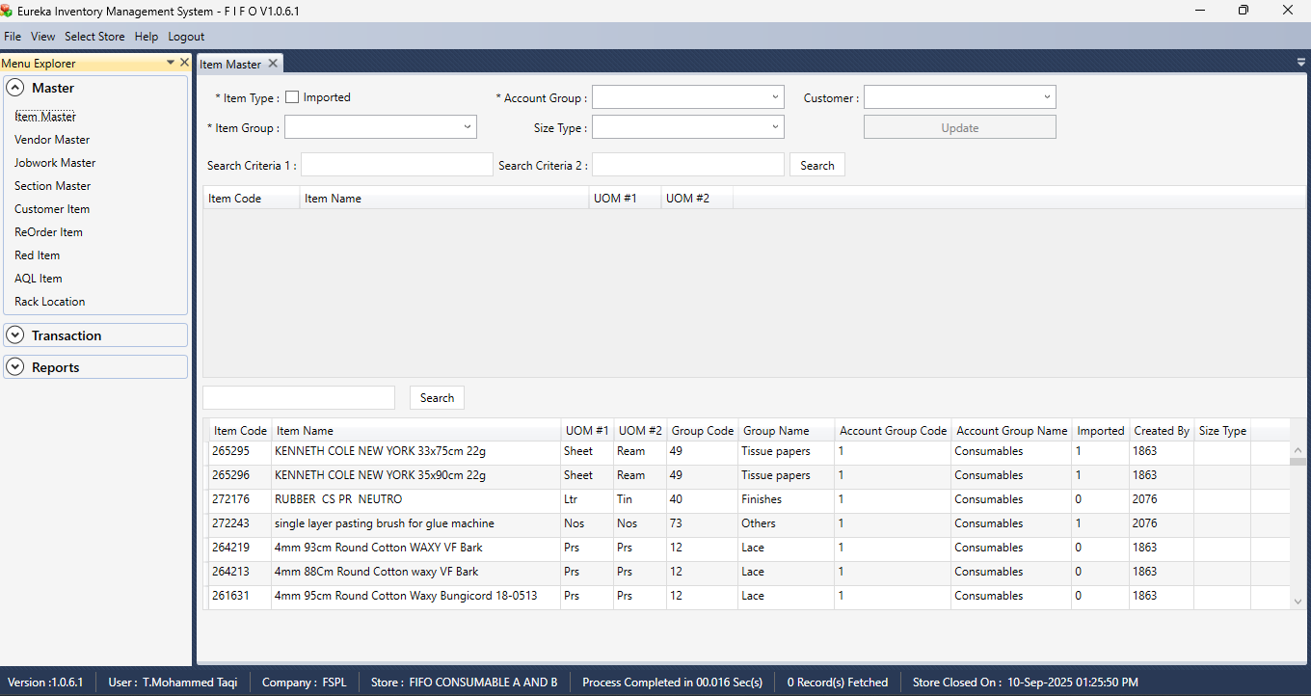

|  |  |
| --- | --- |
|  |  |

Section 2  
  


Section 3

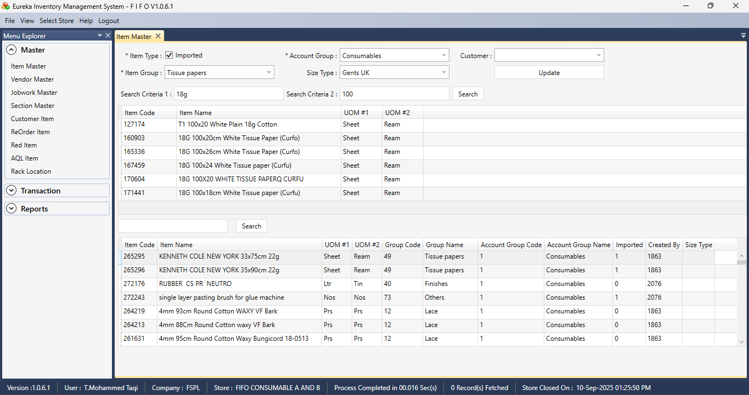

VENDOR MASTER

Section 1  
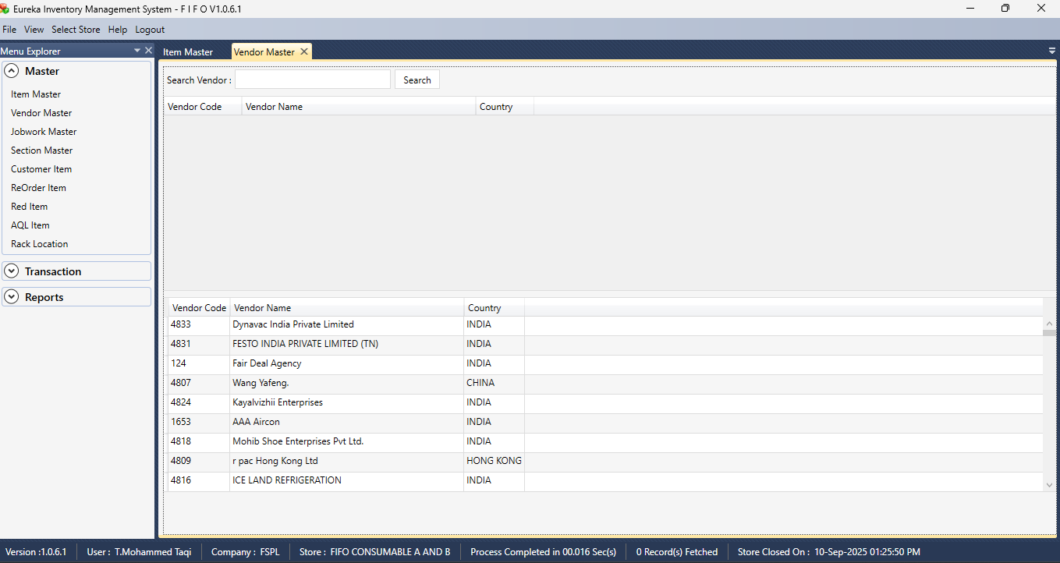  
  
Section 2  
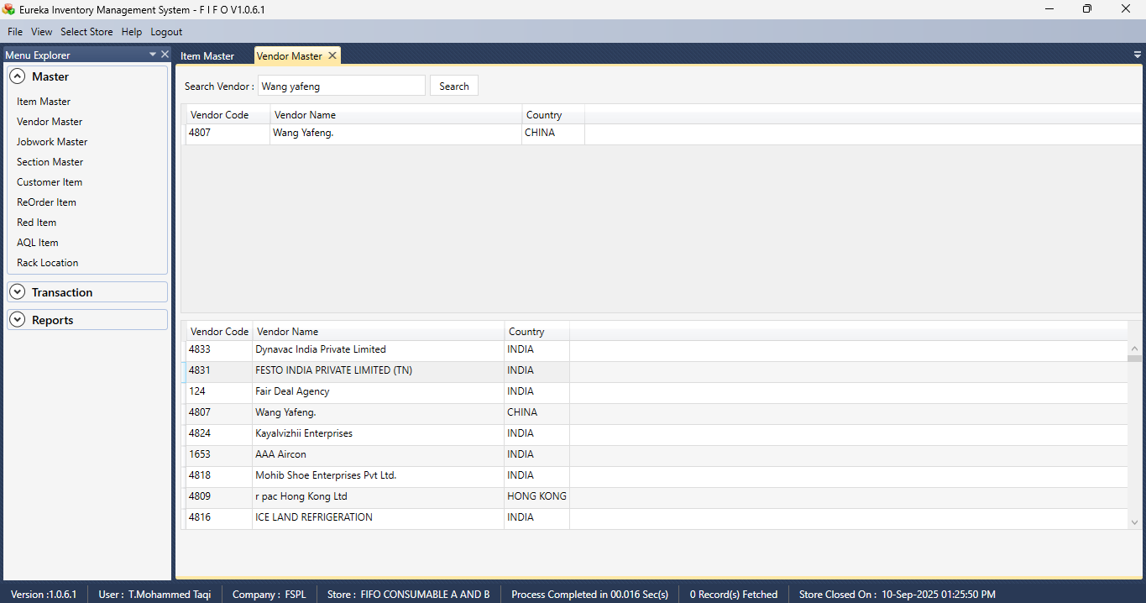

JOBWORK MASTER

Section 1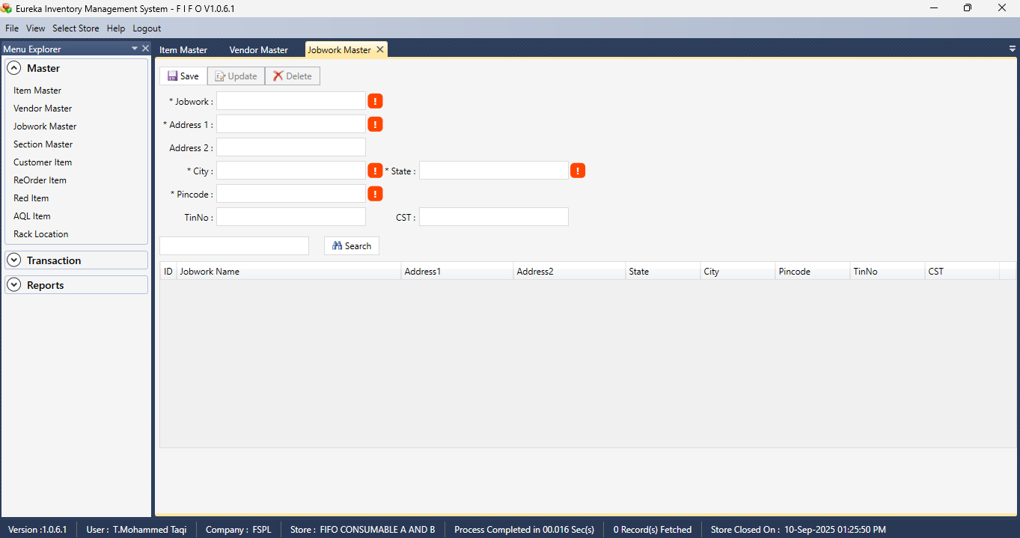  
  
Section 2  
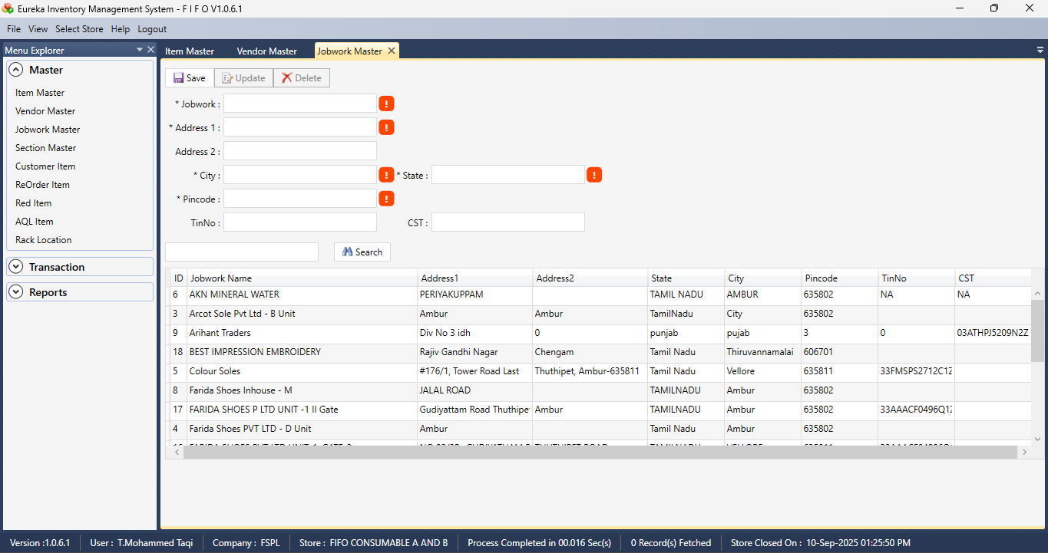

Section 3 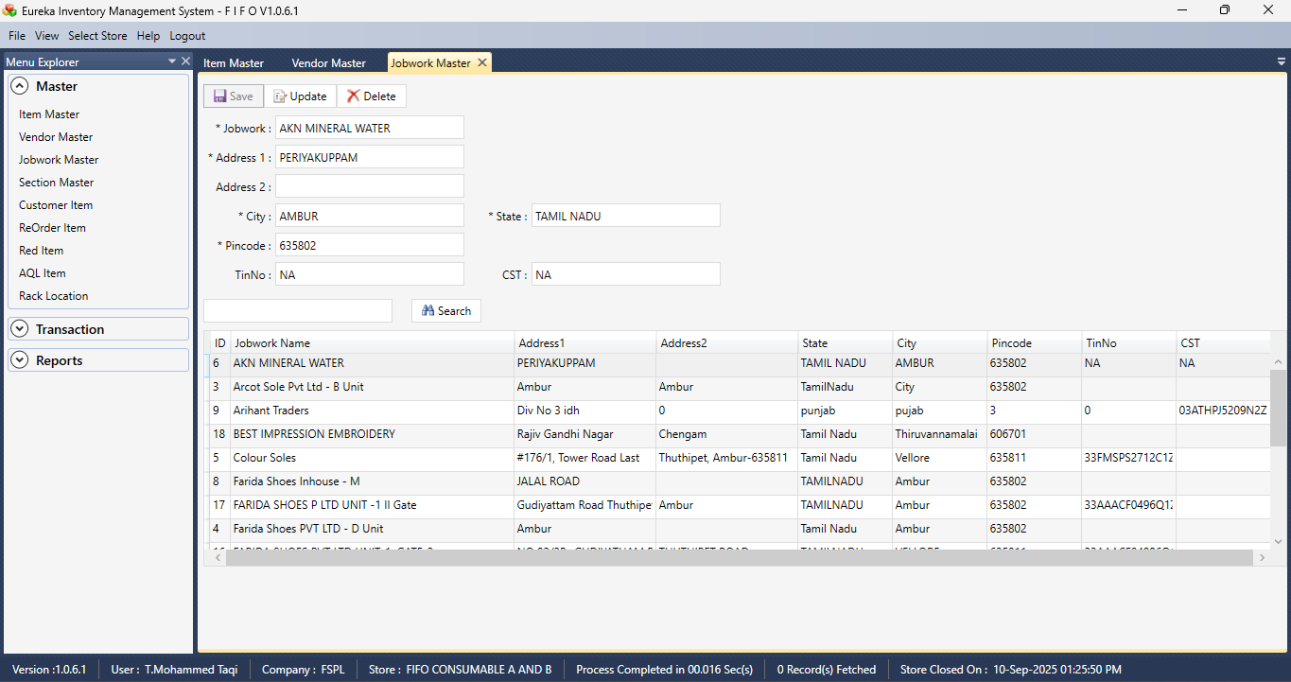

SECTION MASTER

Section 1  
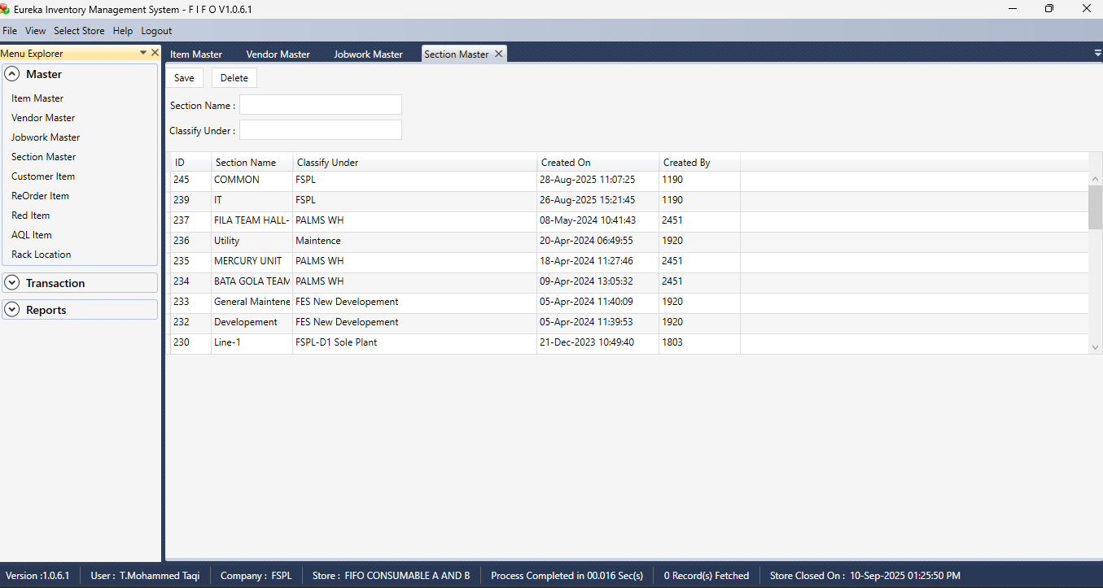

CUSTOMER ITEM

Section 1  
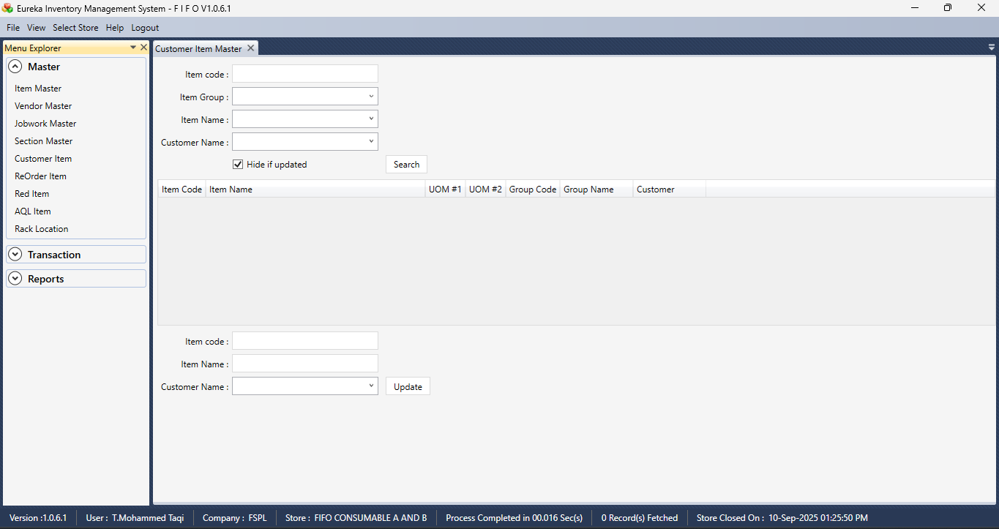  
  
Section 2  
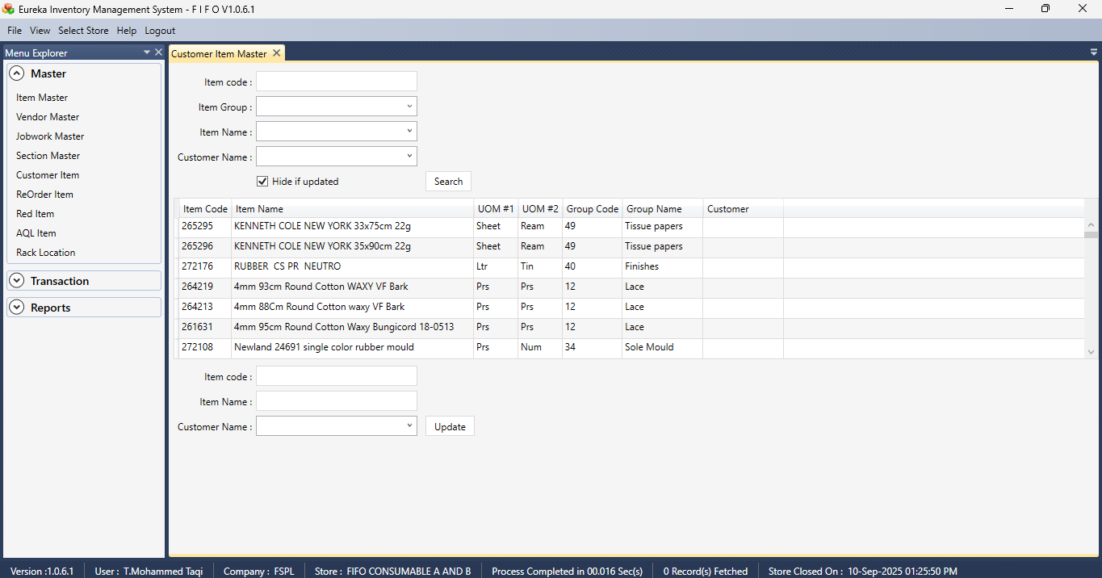

Section 3  
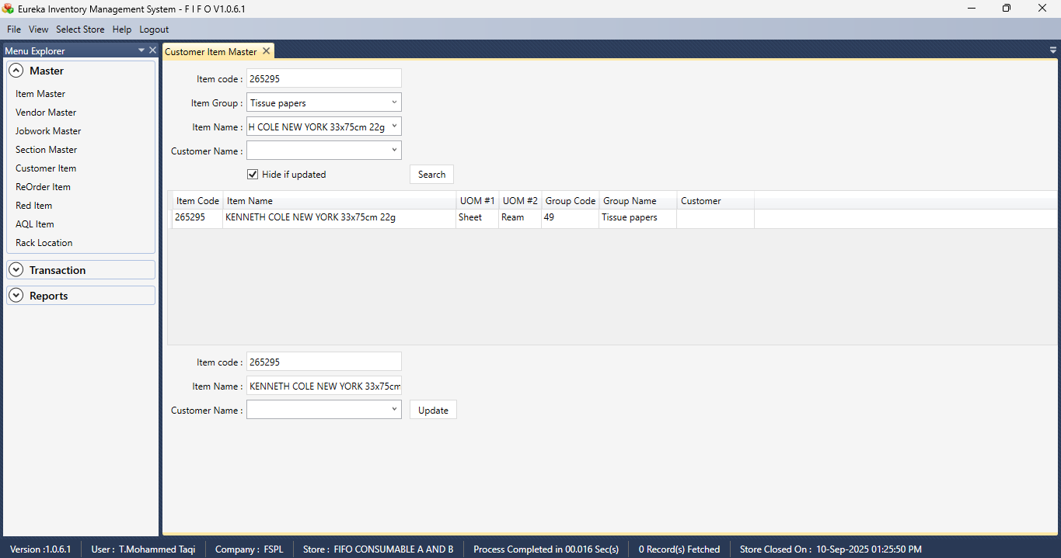

REORDER ITEM  
  
Section 1  
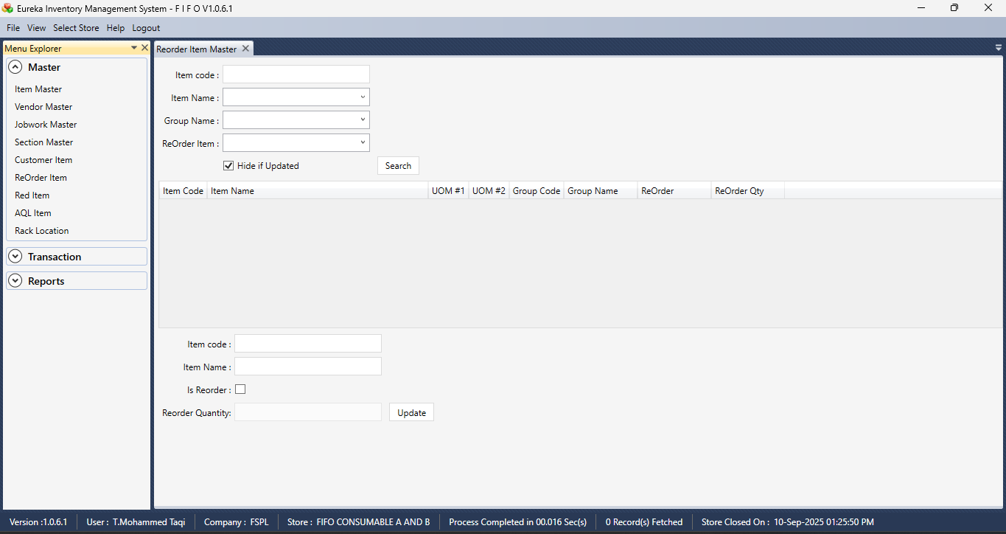

Section 2  
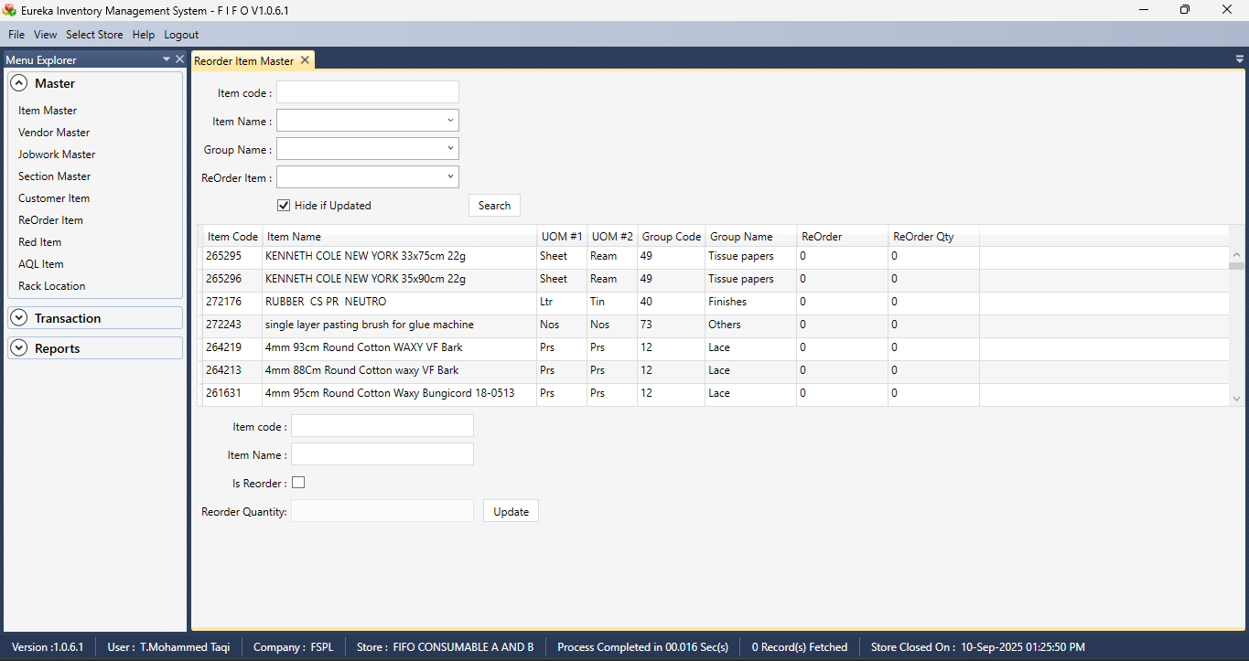

Section 3  
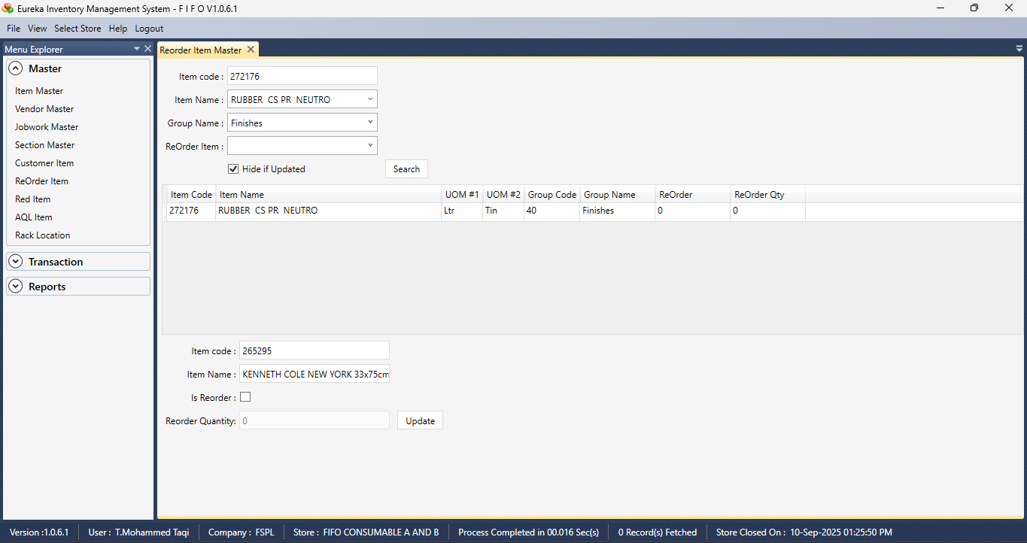

RED ITEM

Section 1  
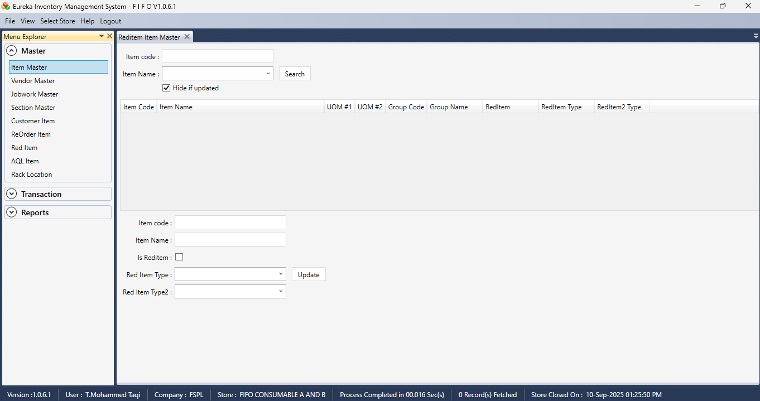

Section 2  
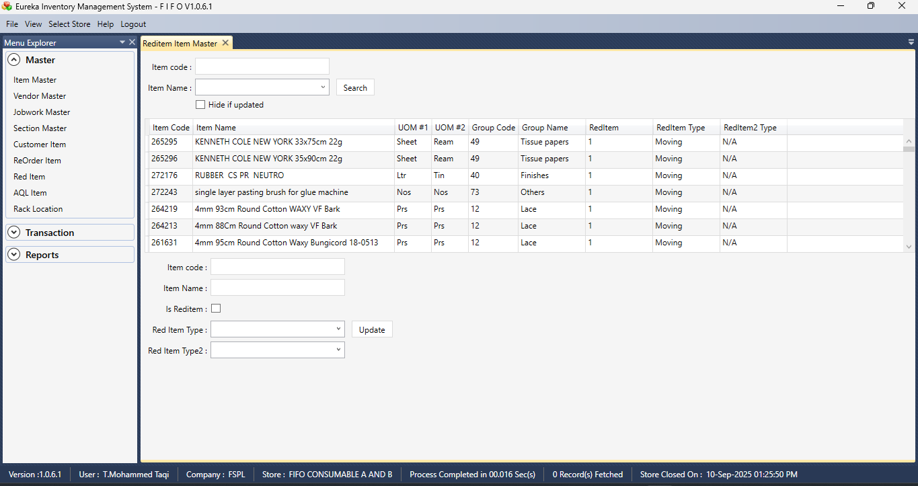

Section 3  
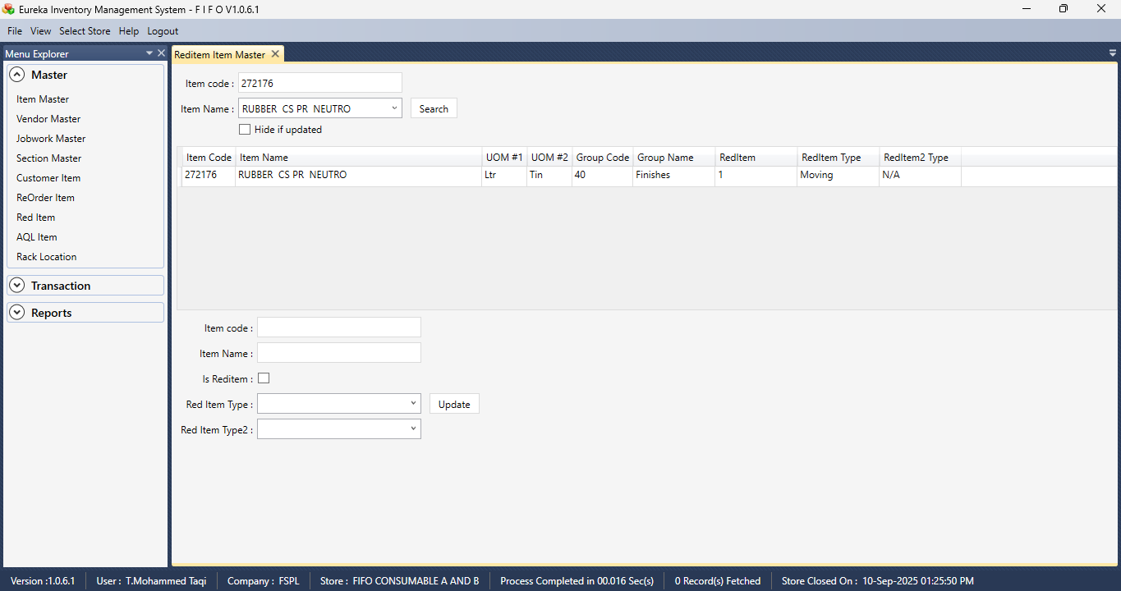

Section 4  
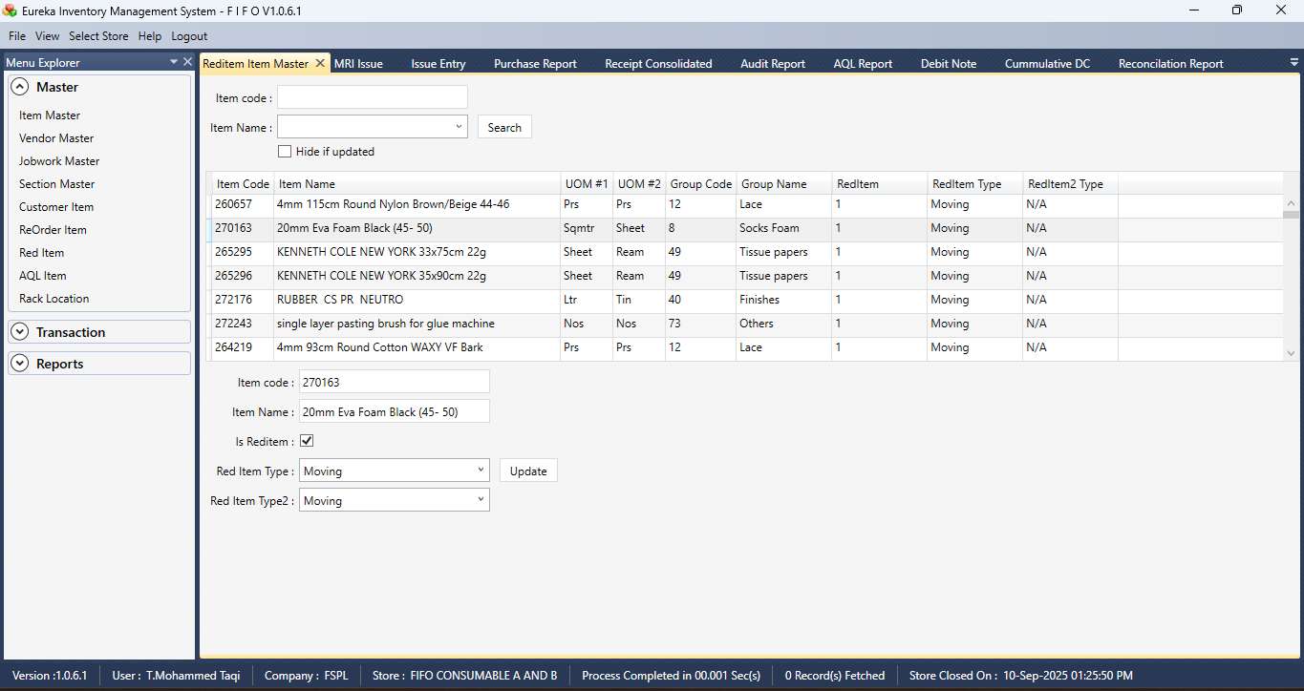

AQL ITEM

Section 1  
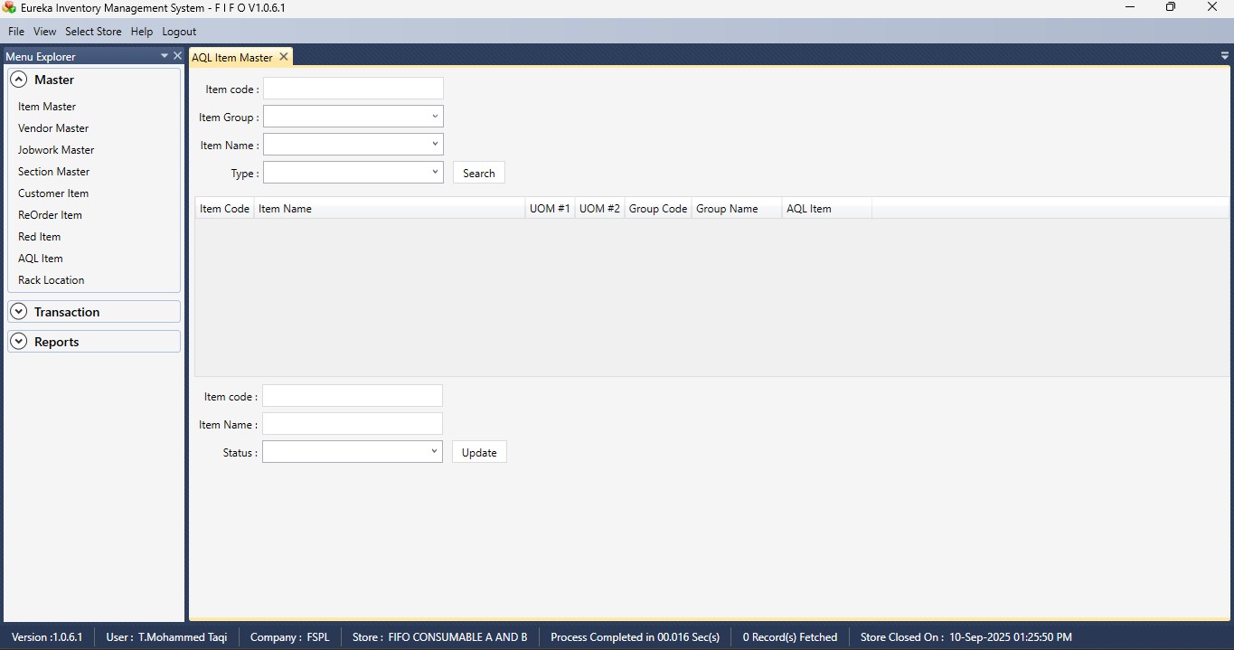  
  
Section 2  
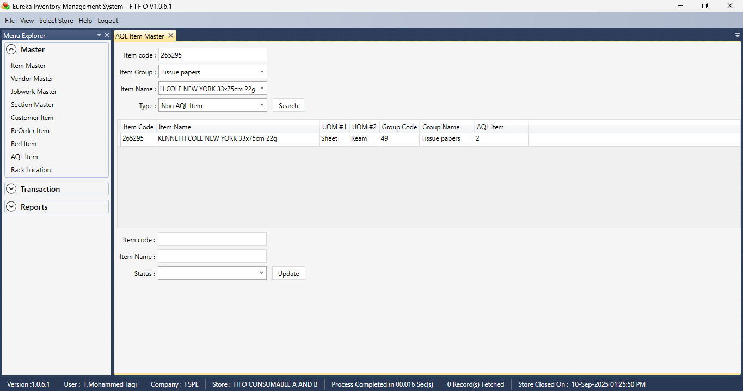

Section 3  
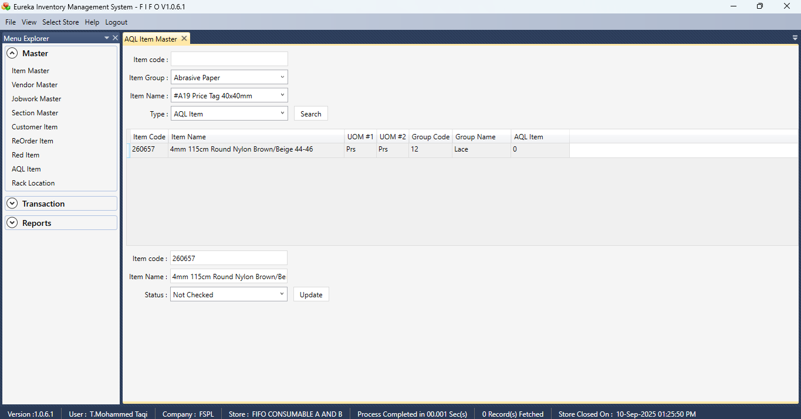

RACK LOCATION  
  
Section 1  
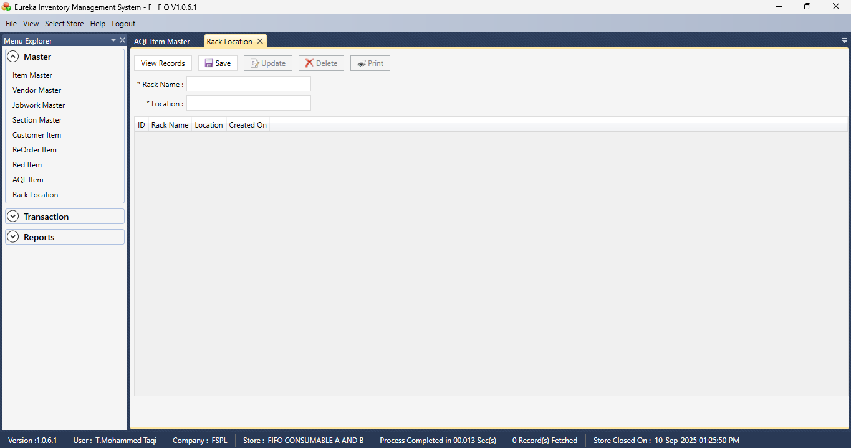

RECEIPT ENTRY

Section 1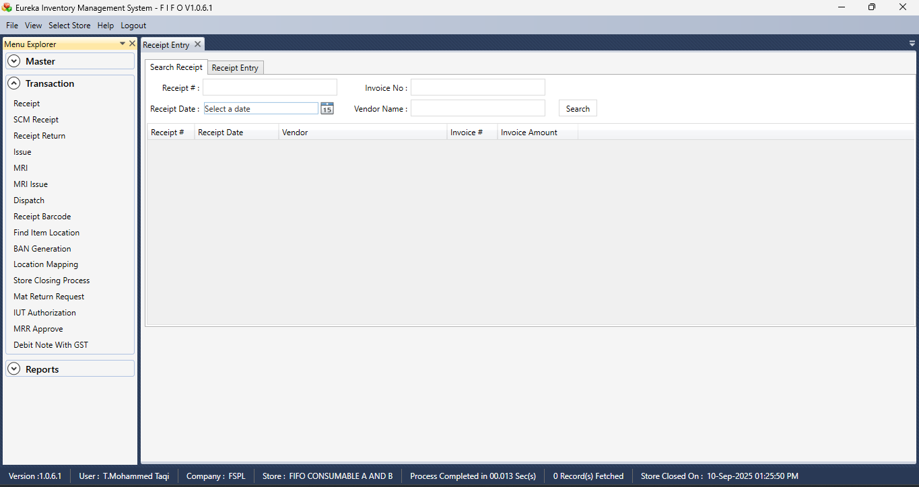

Section 2  
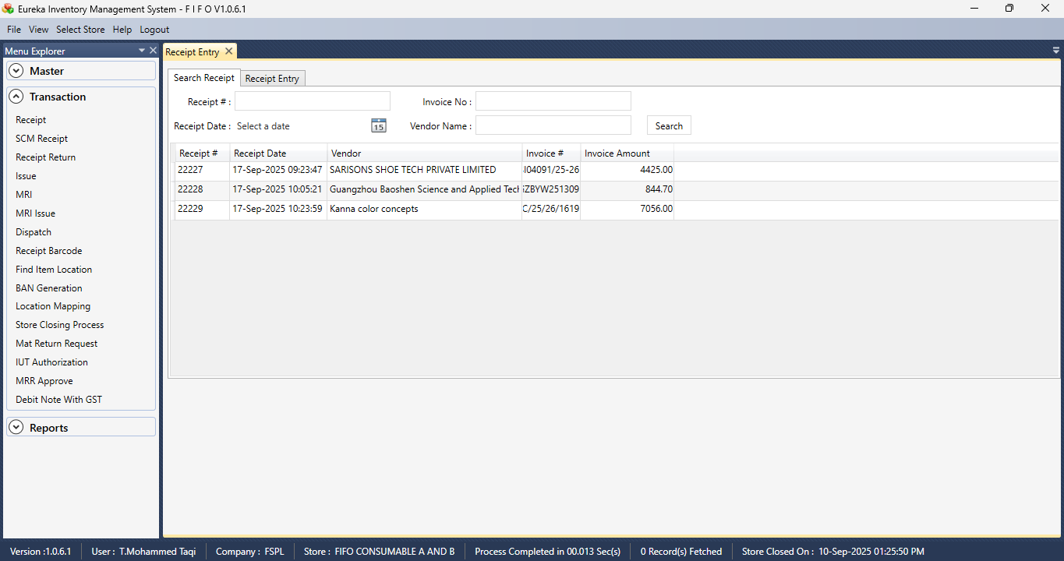

Section 3  
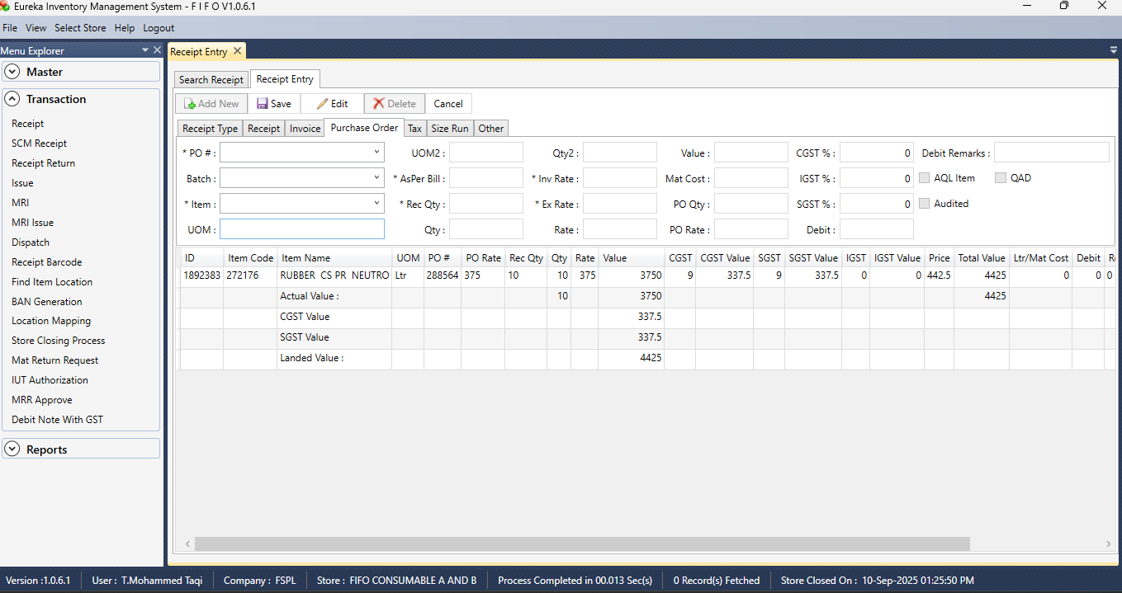

Section 4  
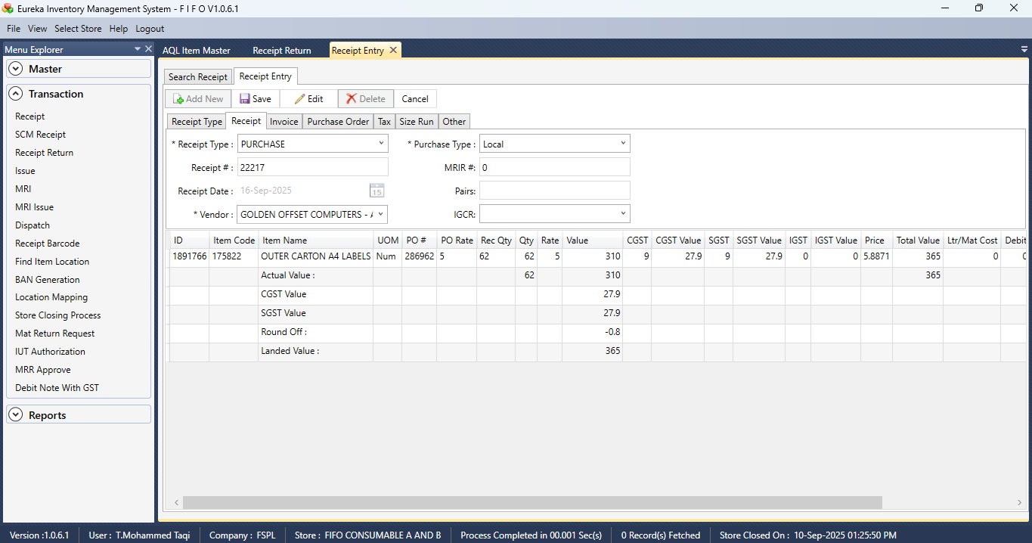

Section 5  
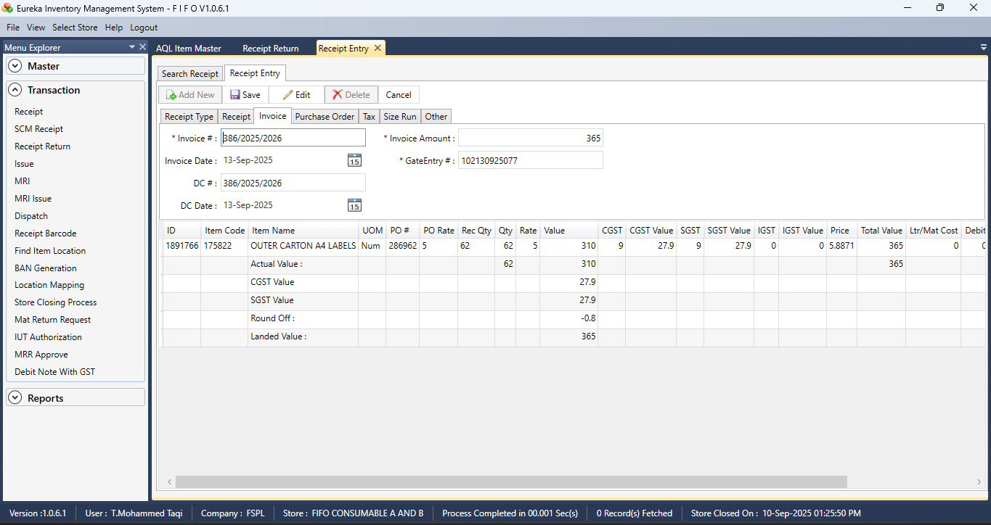

Section 6  
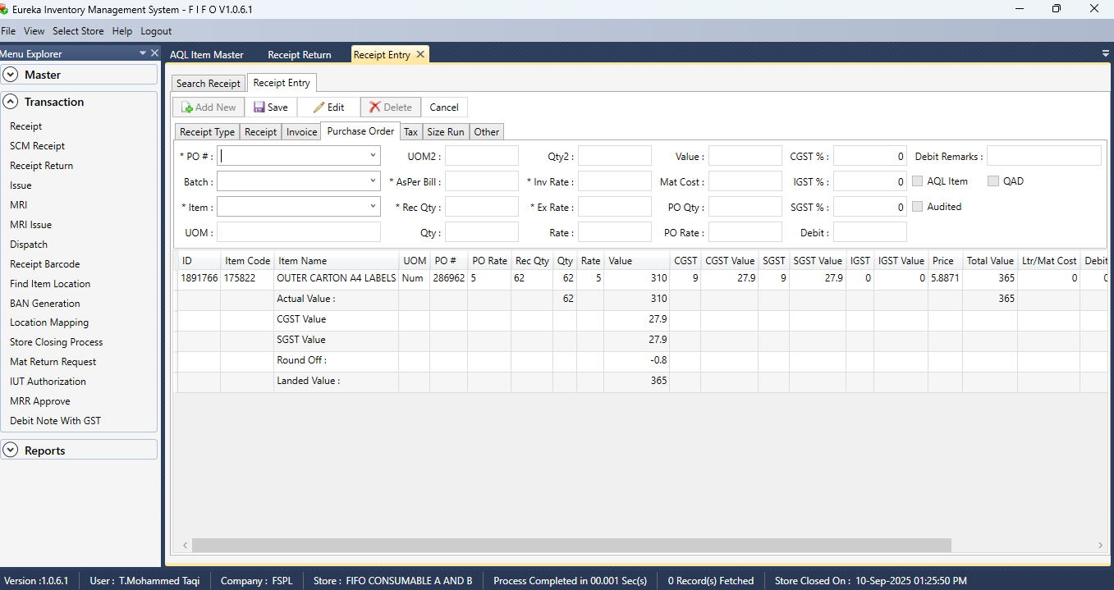

Section 7  
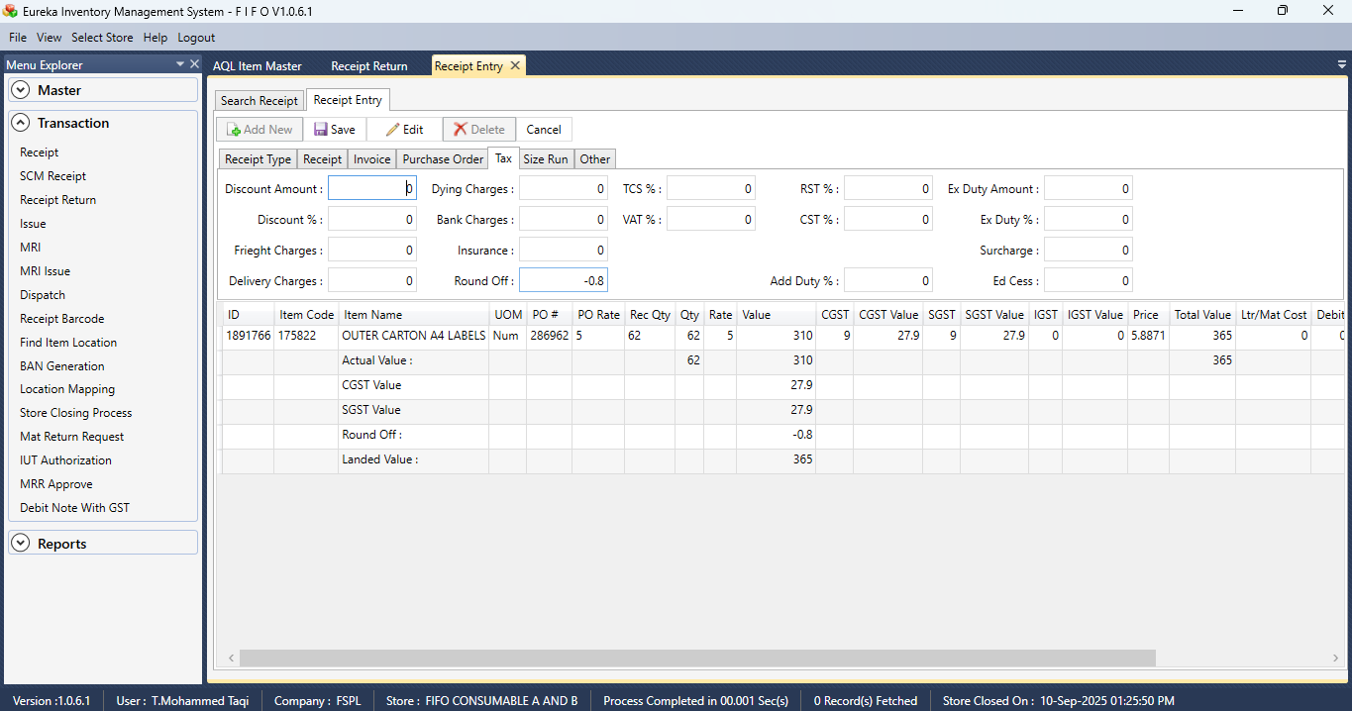

Section 8  
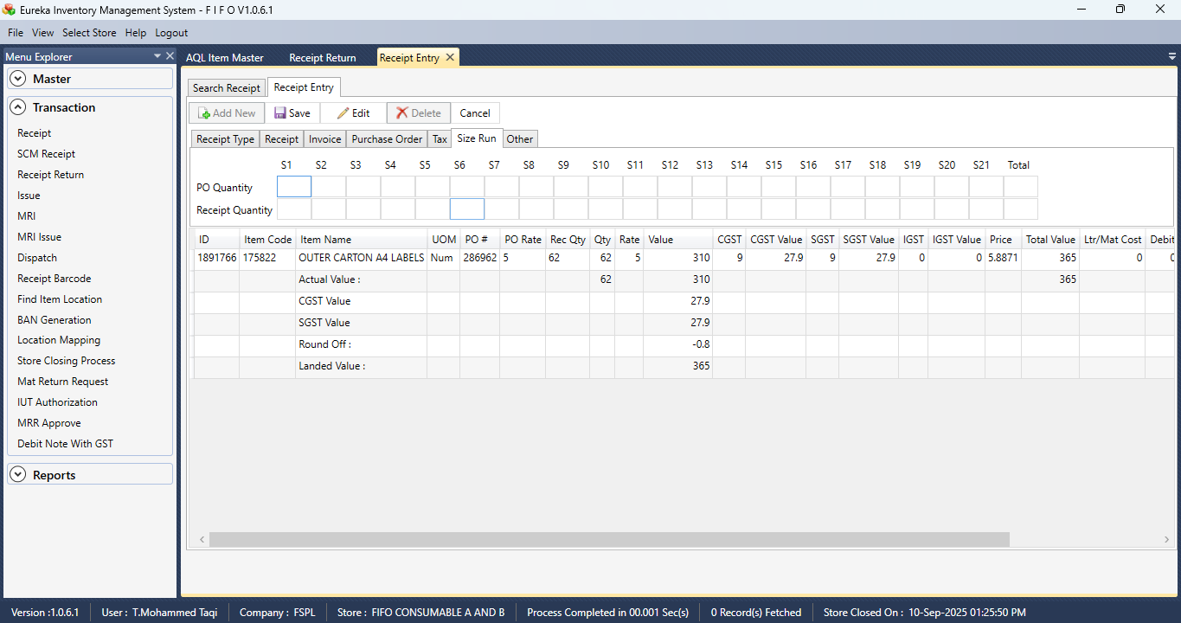

Section 9  
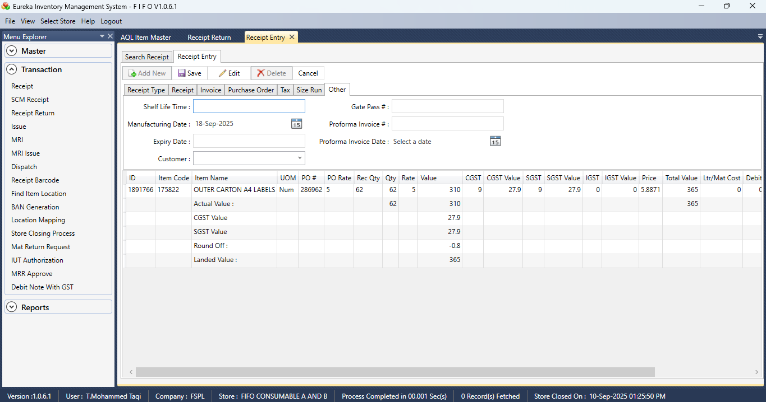

SCM RECEIPT  
  
Section 1  
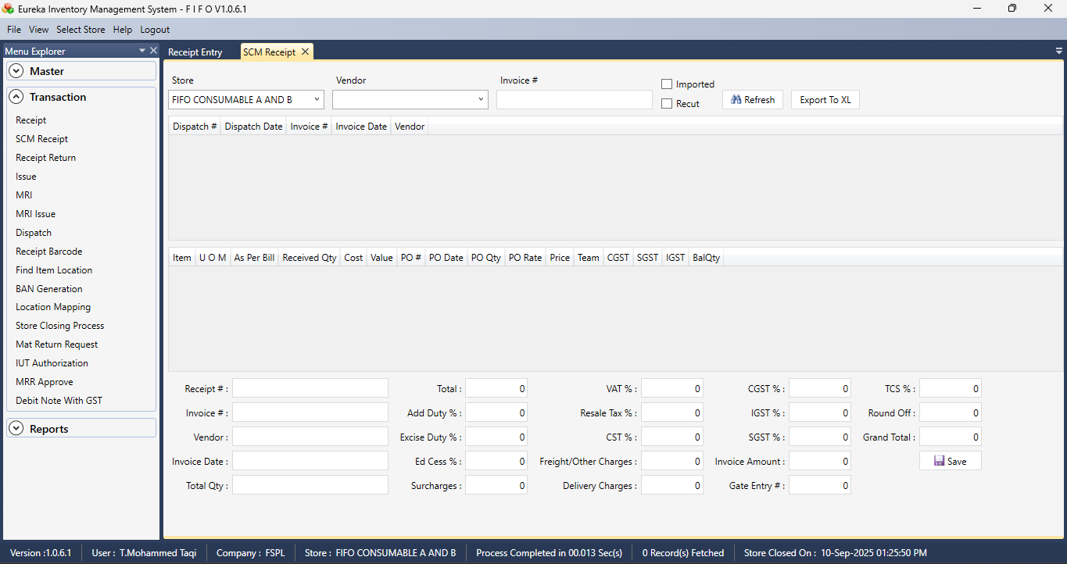

Section 2  
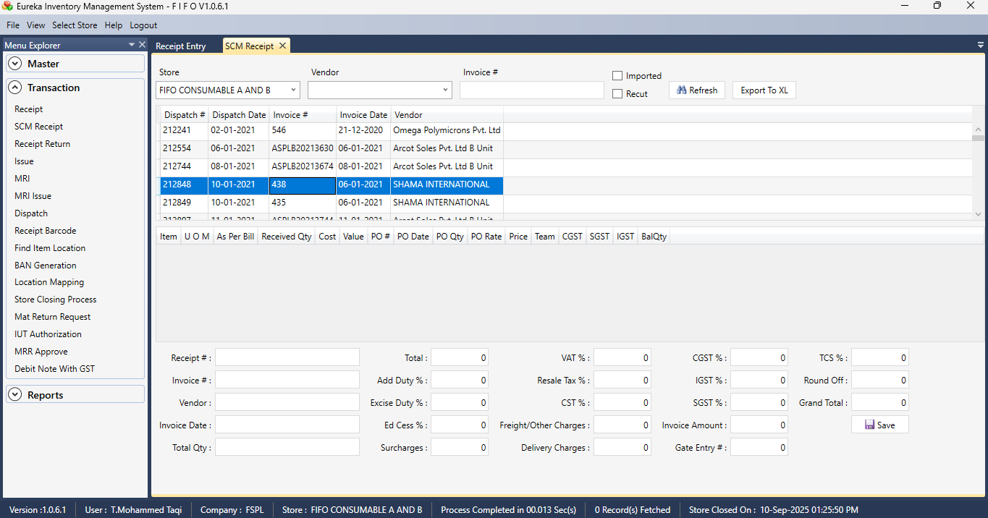

Section 3  
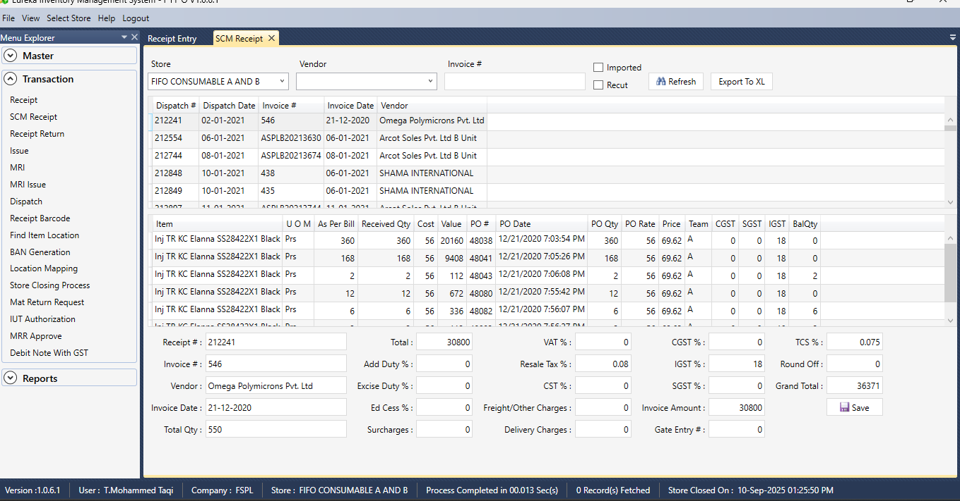

RECEIPT RETURN

Section 1  
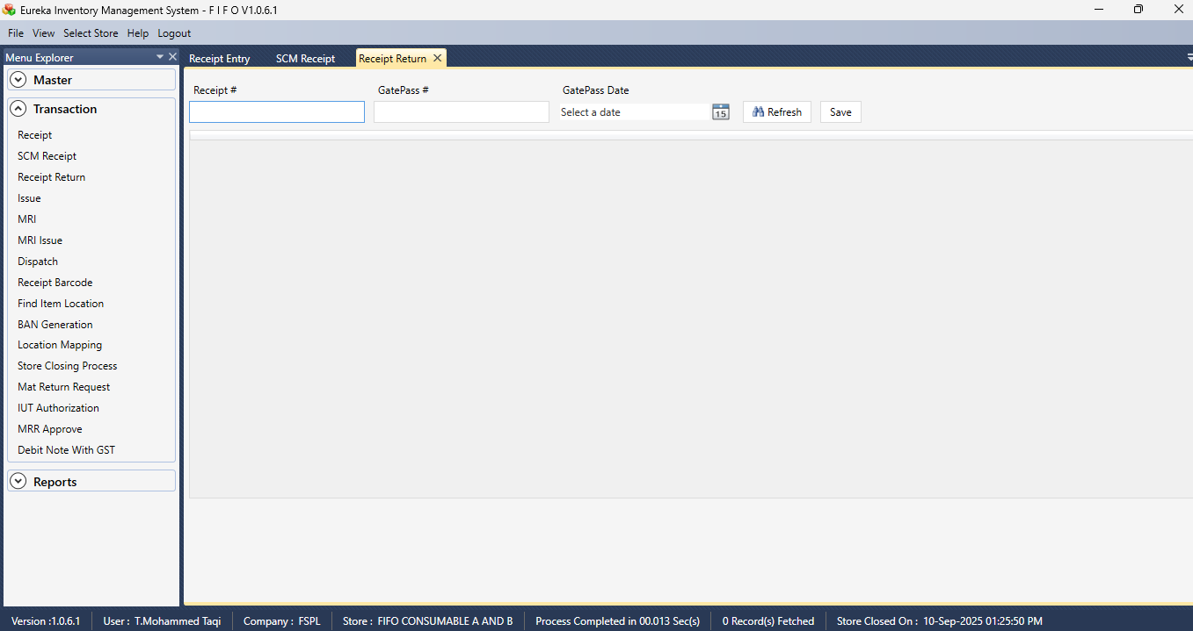

ISSUE ENTRY  
  
Section 1  
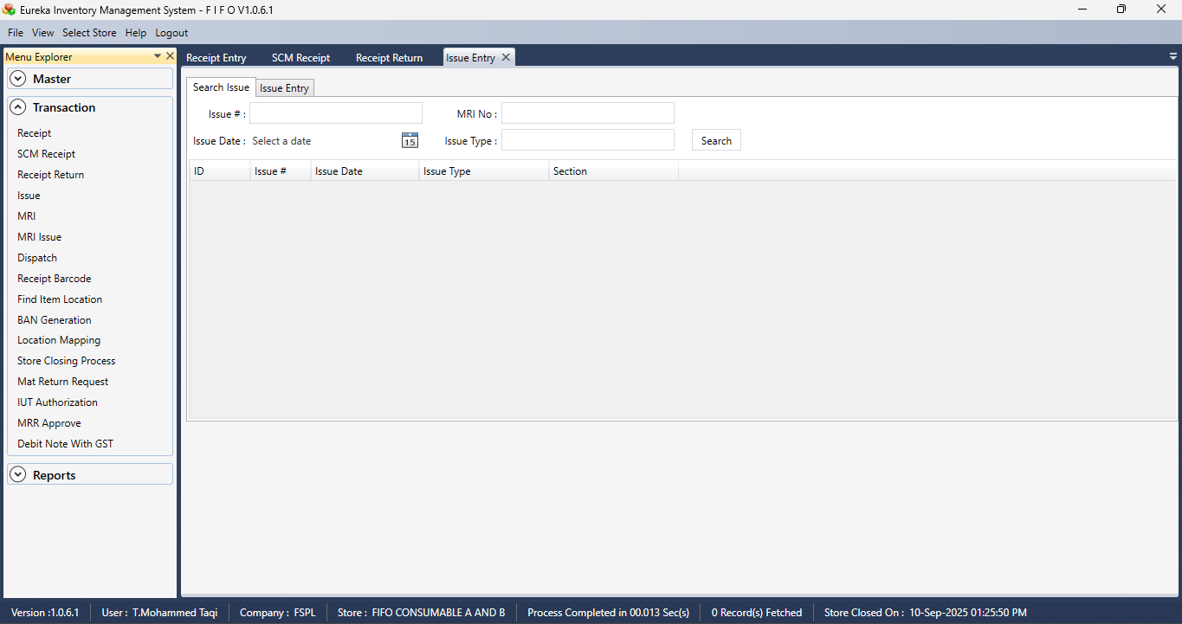

Section 2  
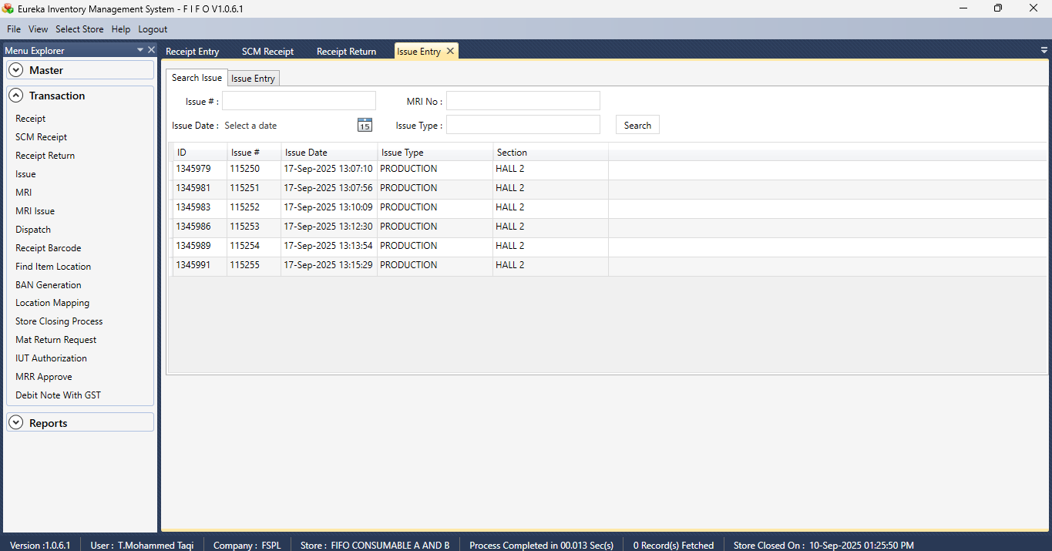

Section 3  
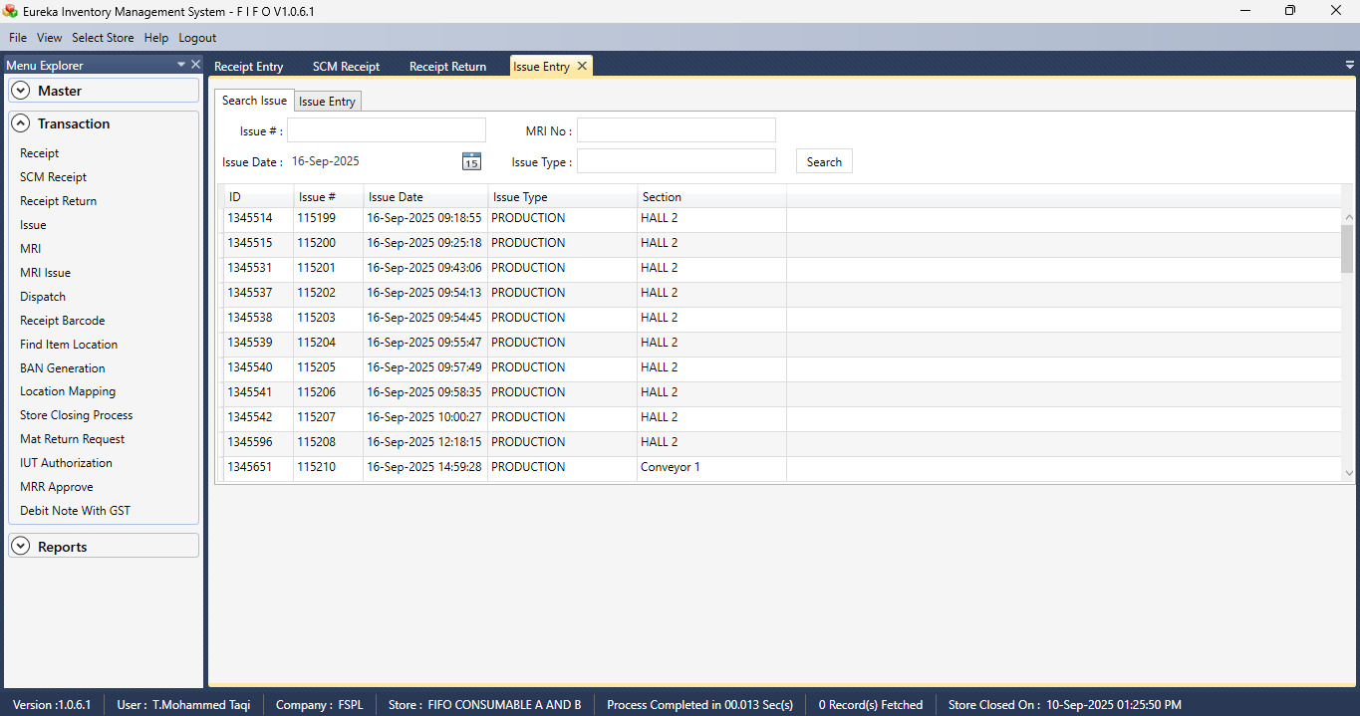

Section 4  
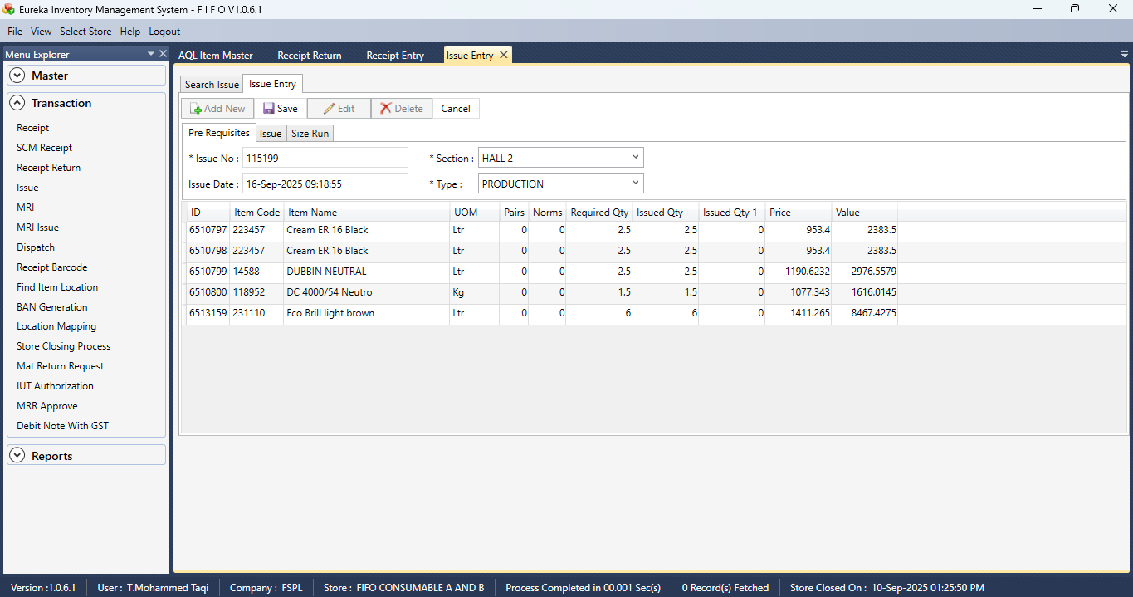

Section 5  
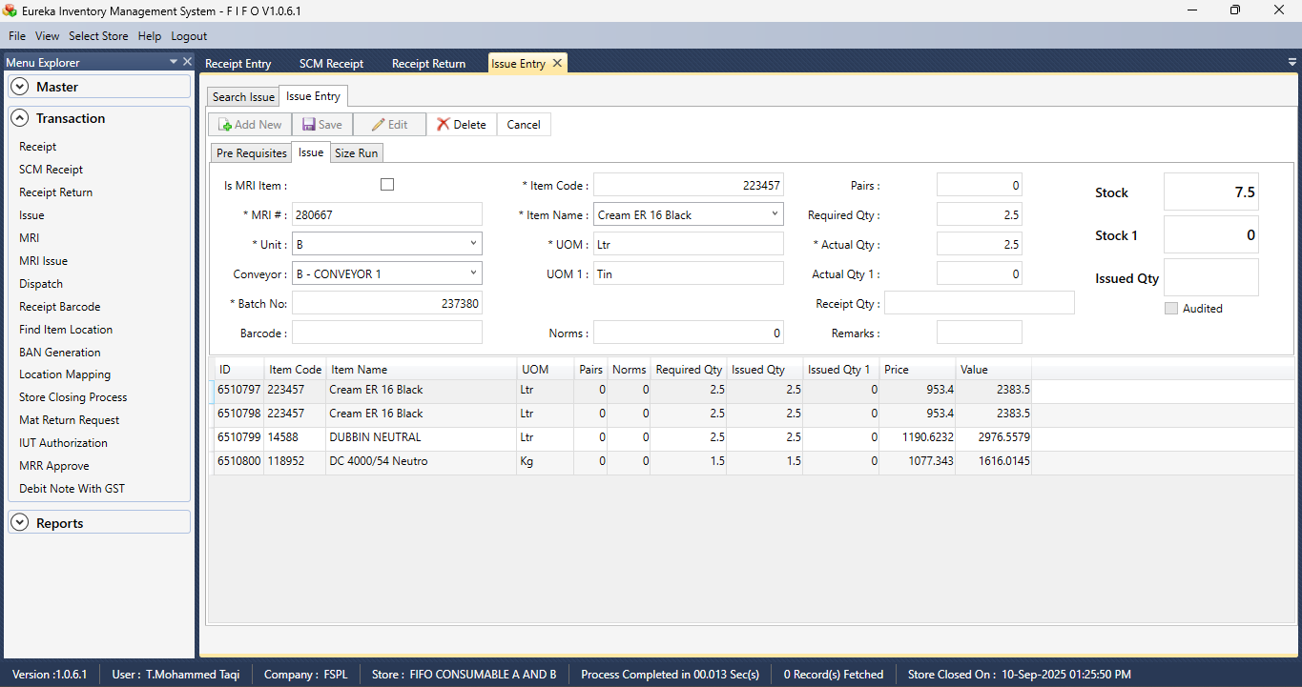

Section 6  
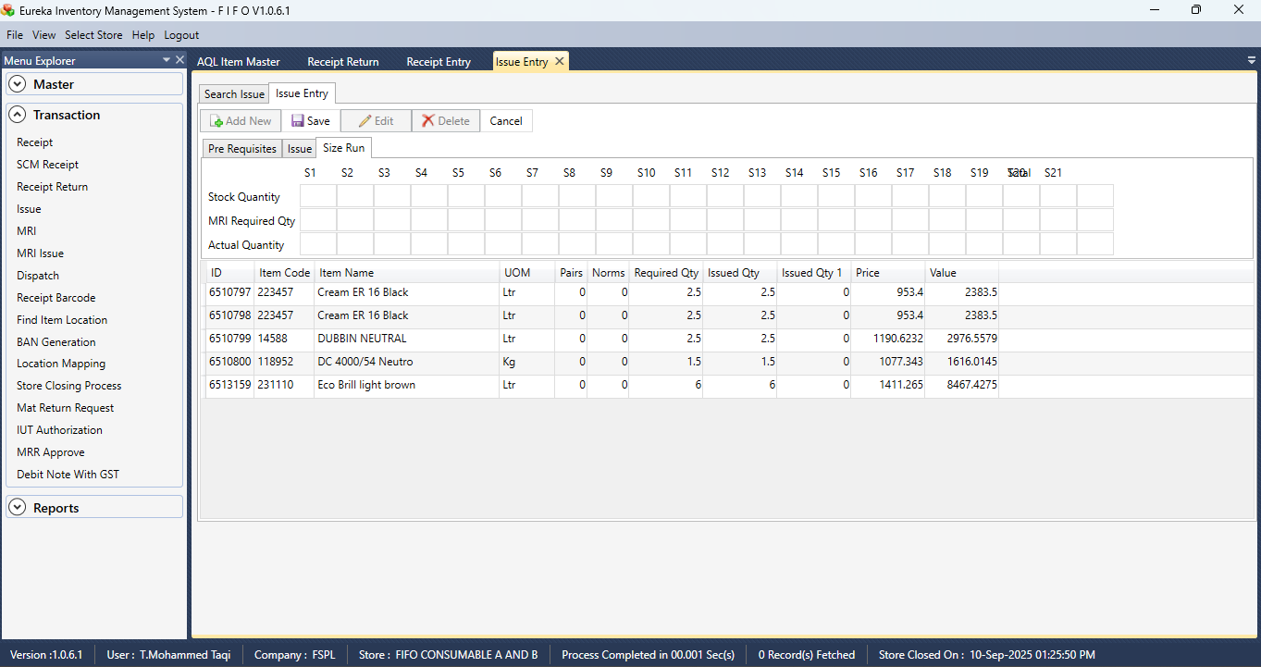

MRI  
  
Section 1  
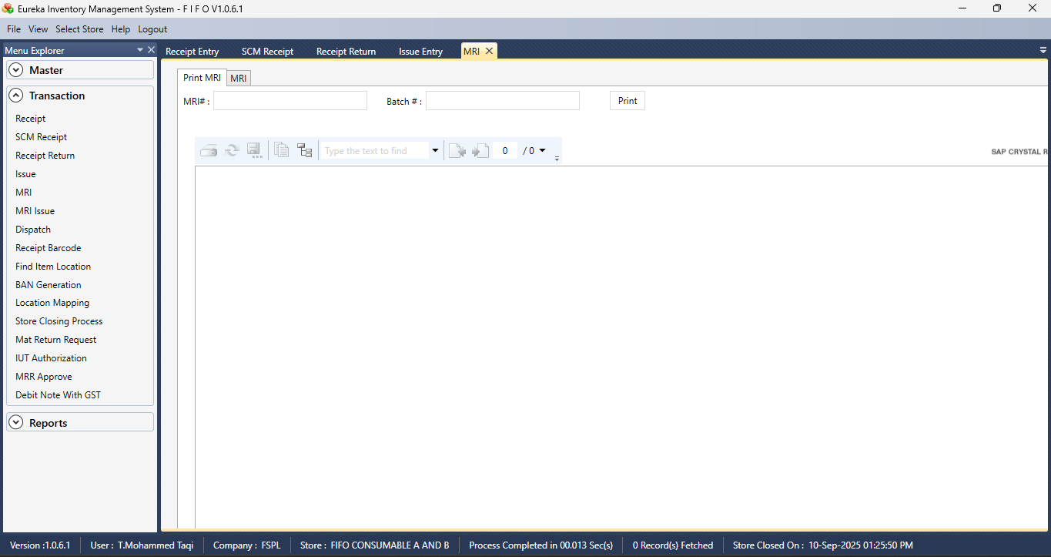

MRI ISSUE

Section 1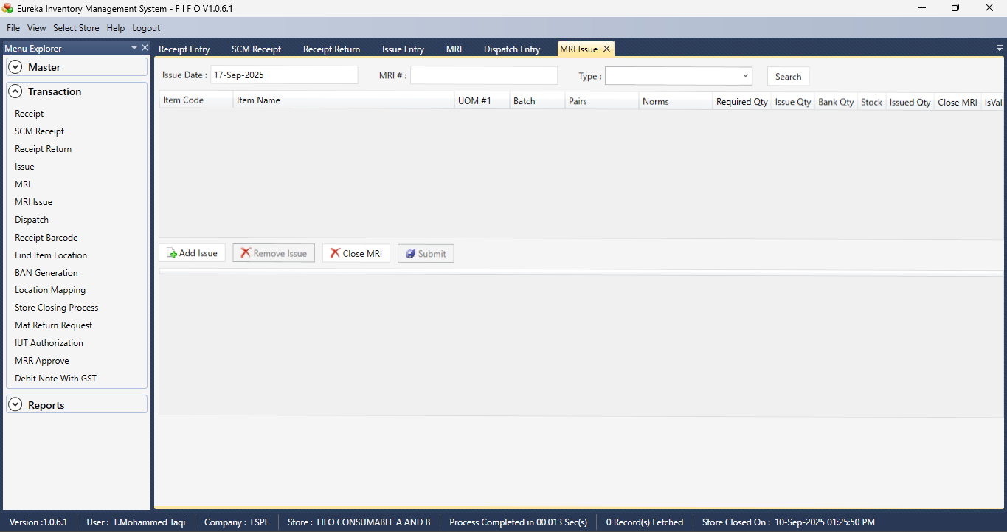

DISPATCH ENTRY

Section 1  
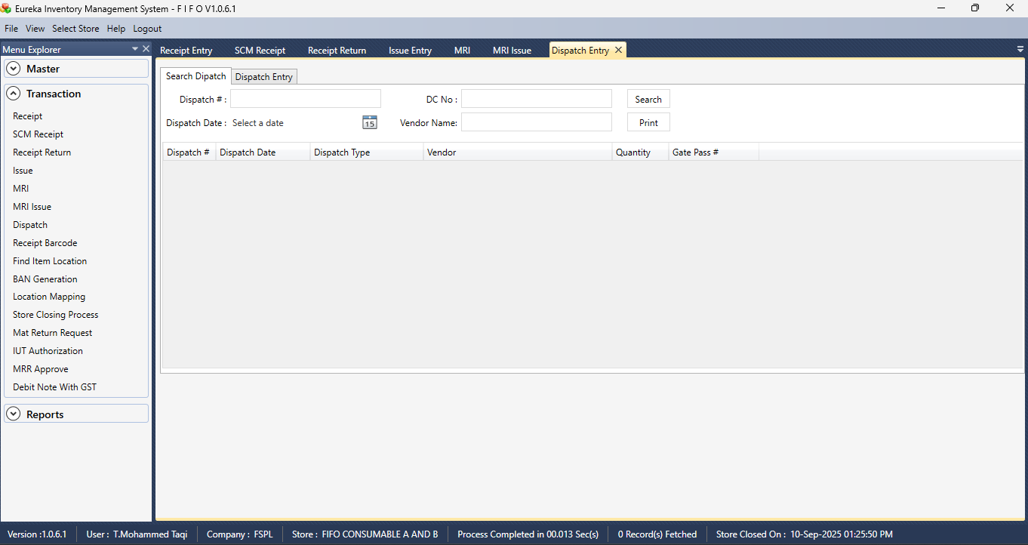

Section 2  
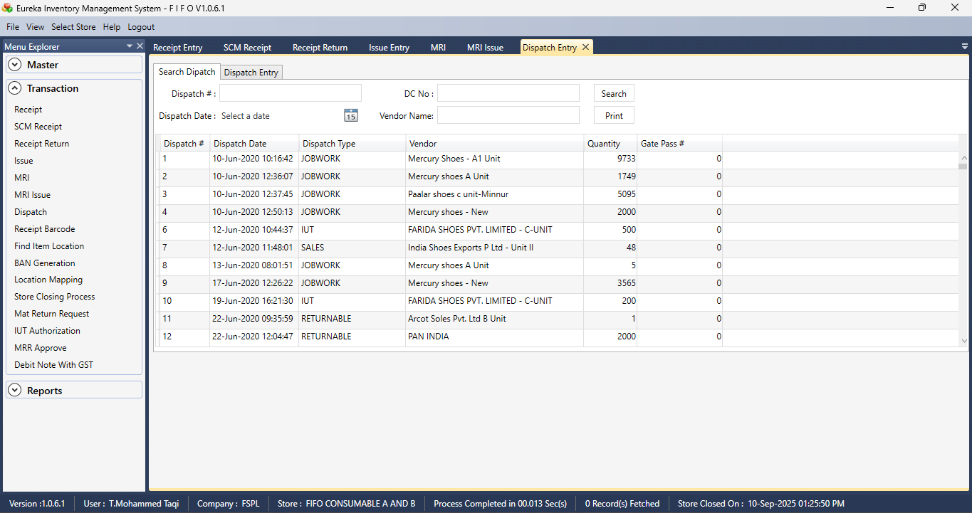

Section 3  
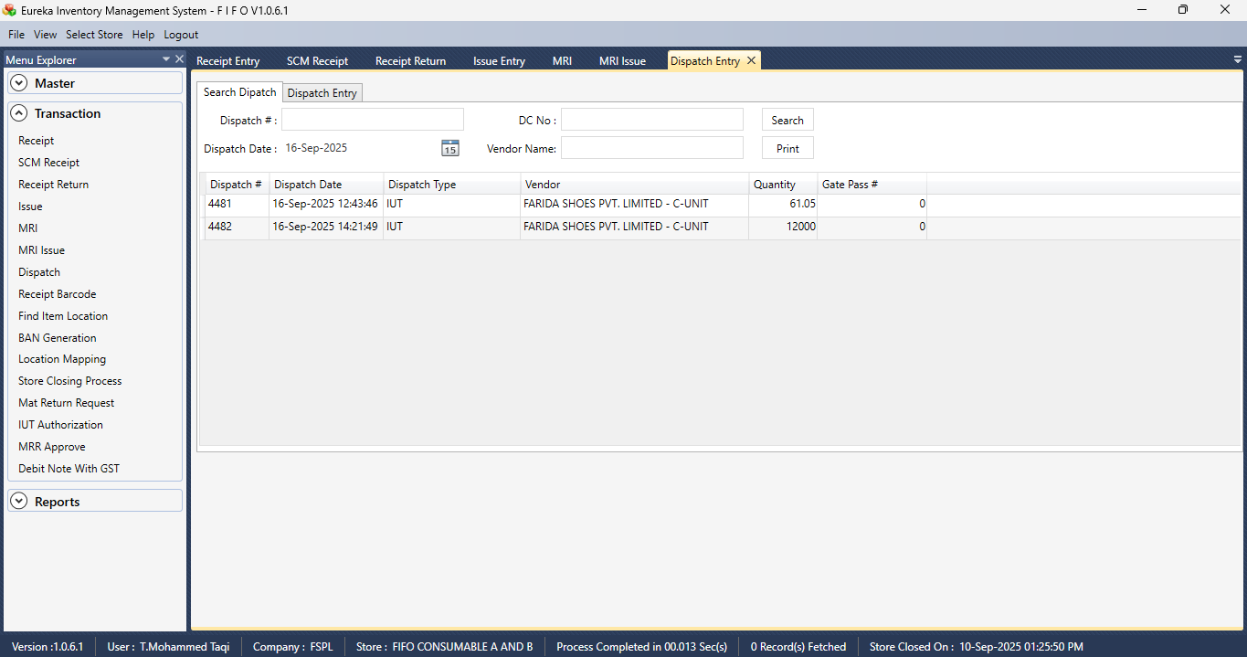

Section 4  
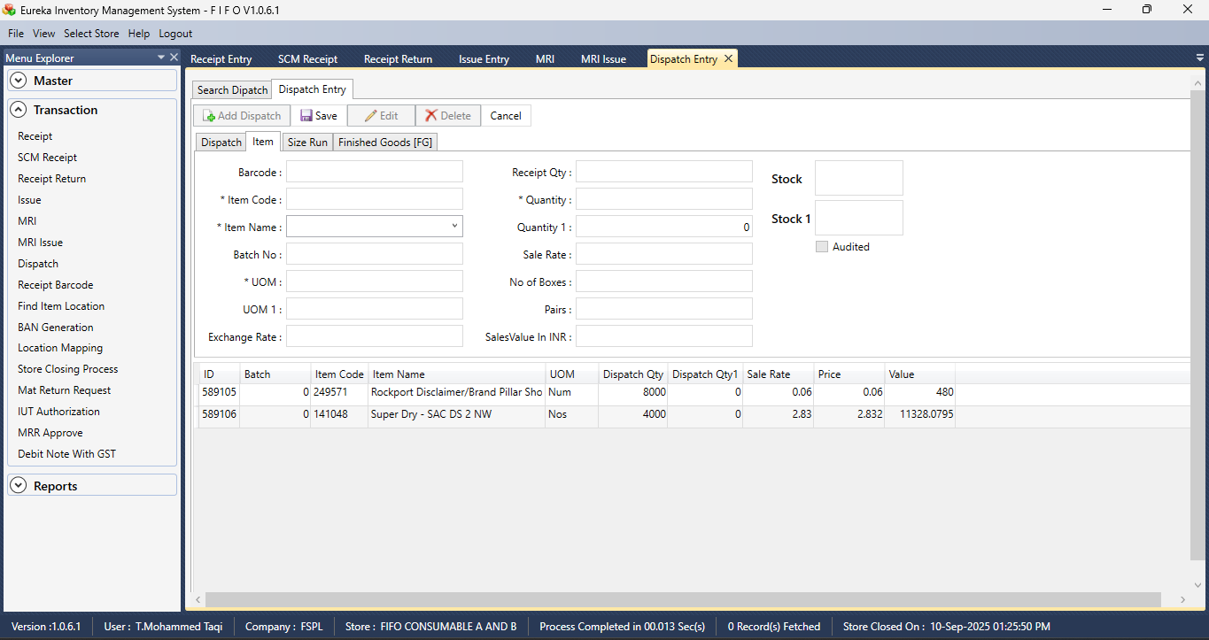

Section 5  
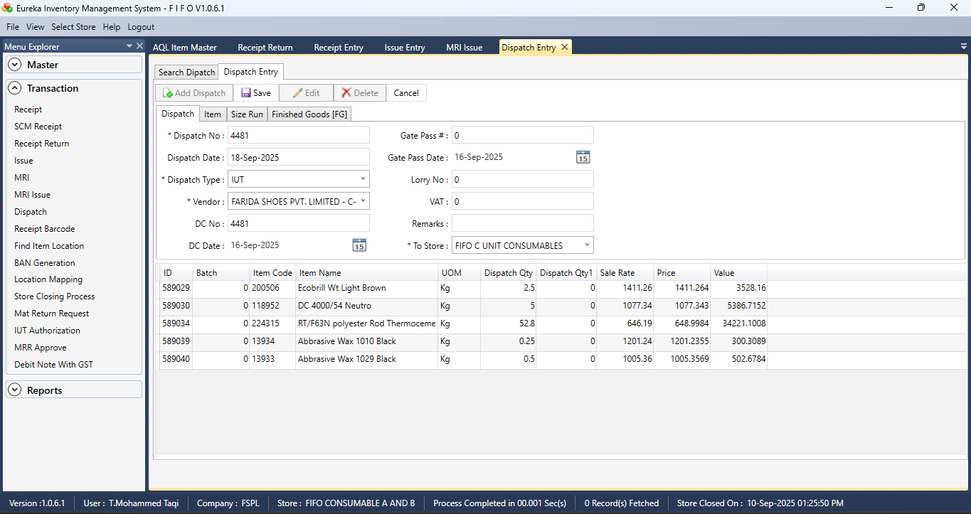

Section 6  
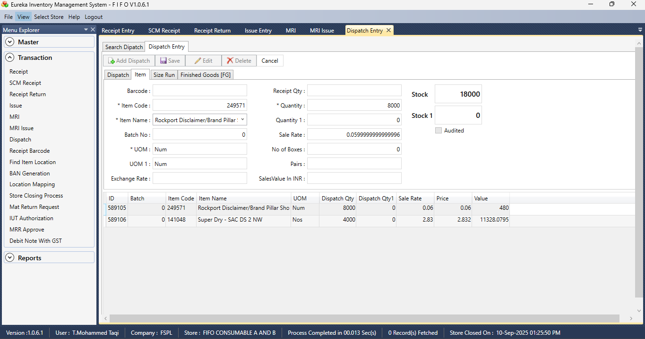

Section 7  
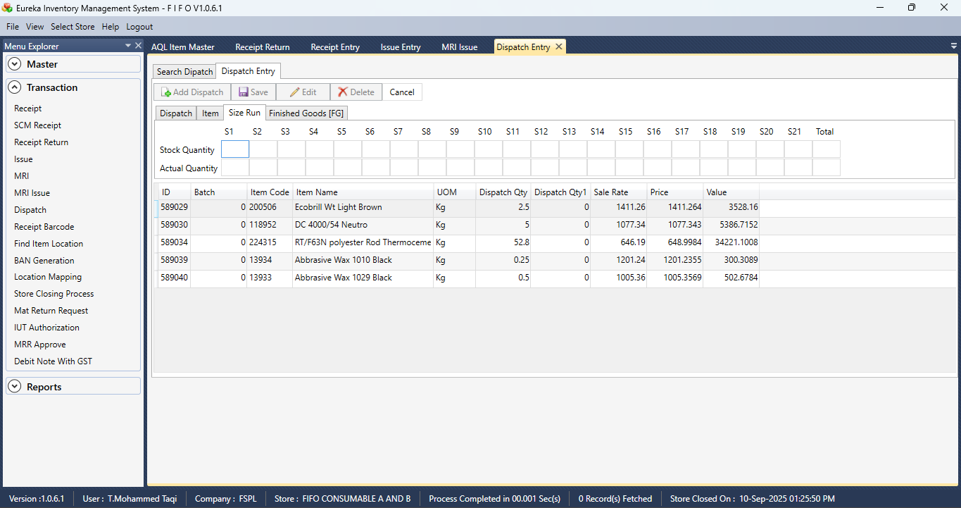

Section 8  
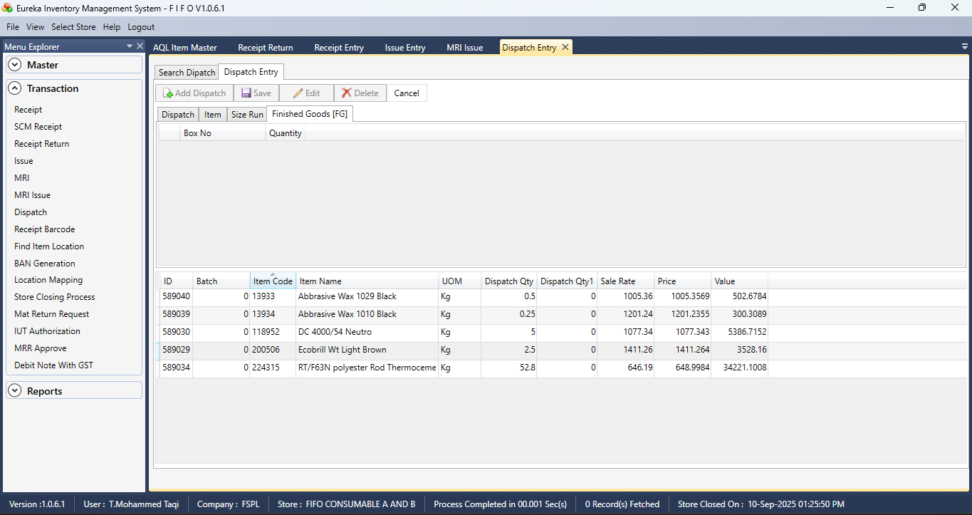

RECEIPT BARCODE

Section 1  
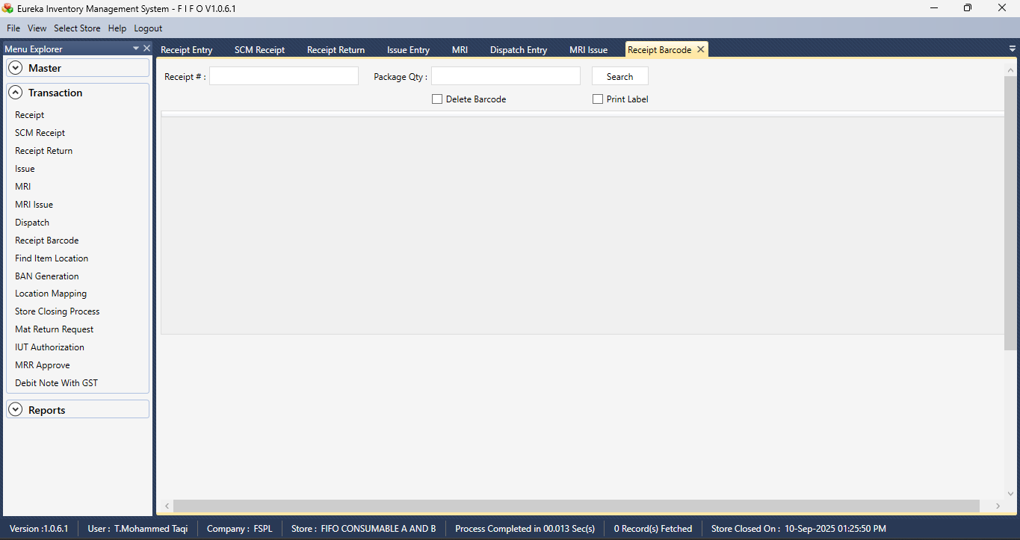

Section 2  
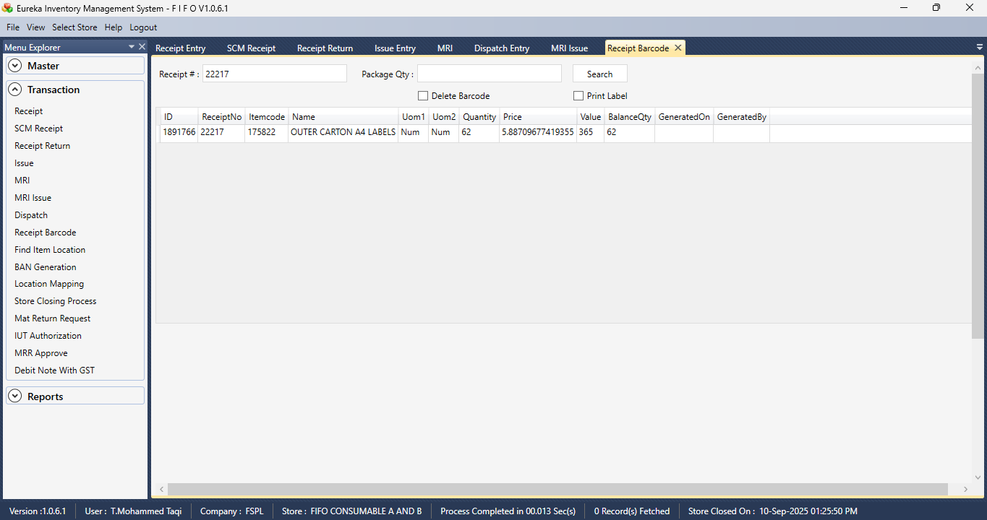

FIND ITEM LOCATION

Section 1  
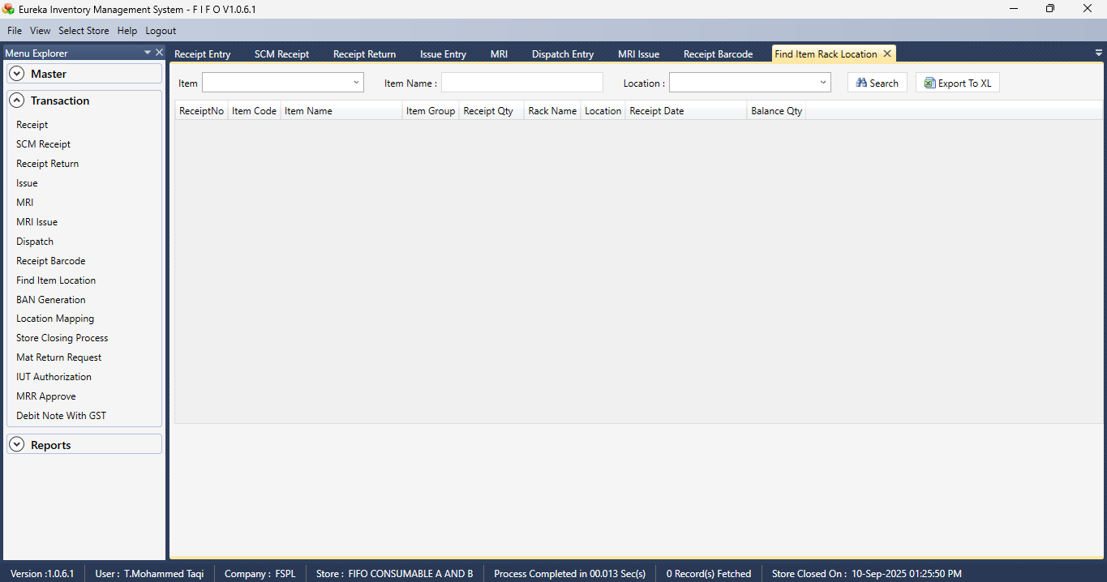

BAN GENERATION

Section 1  
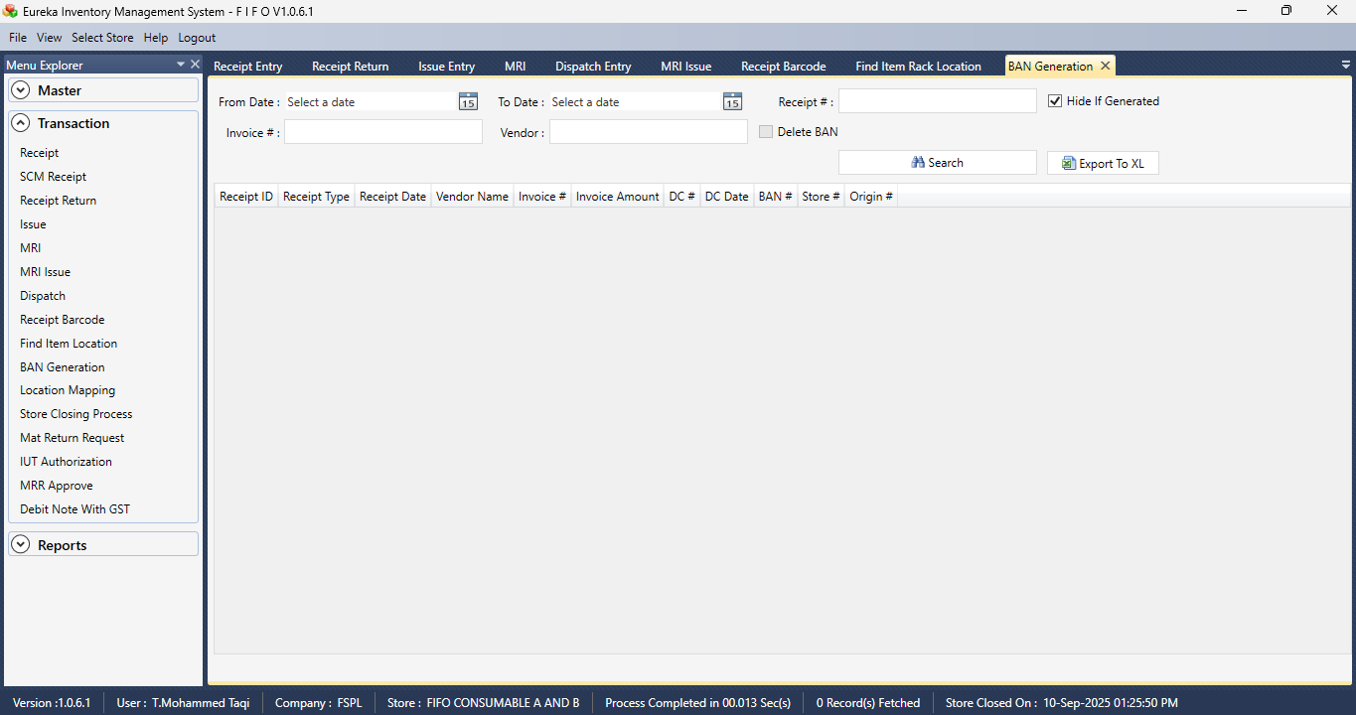

Section 2  
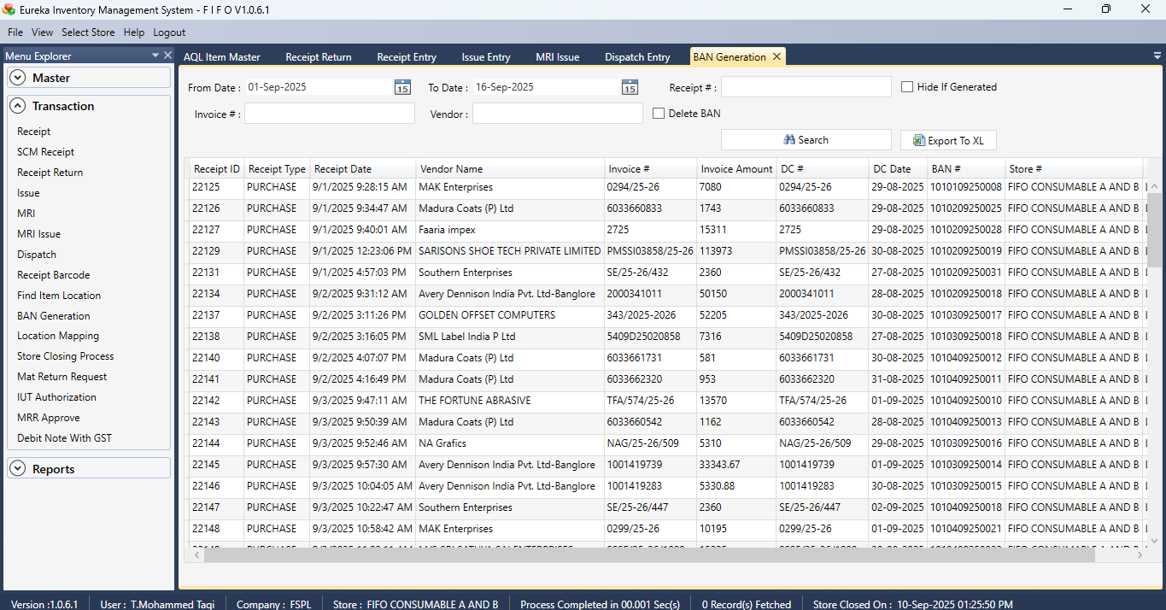

RACK LOCATION MAPPING

Section 1  
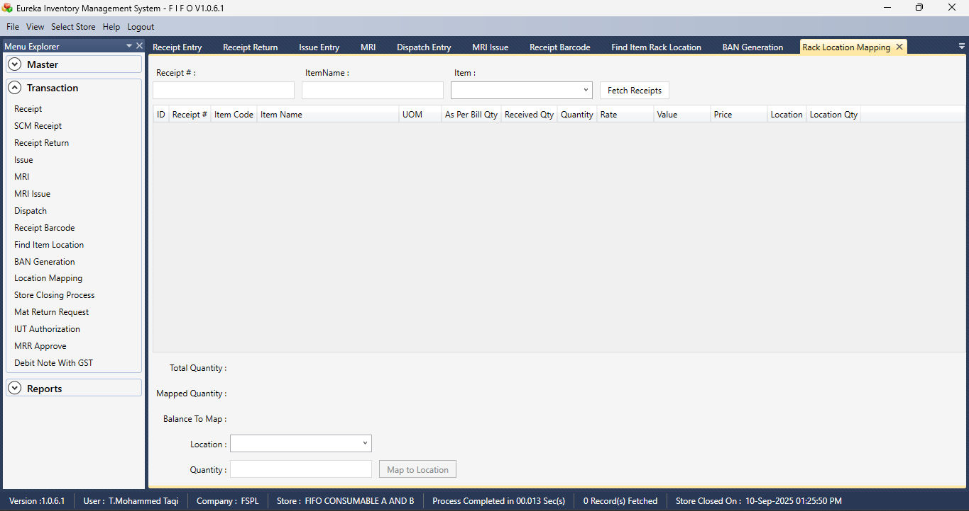

Section 2  
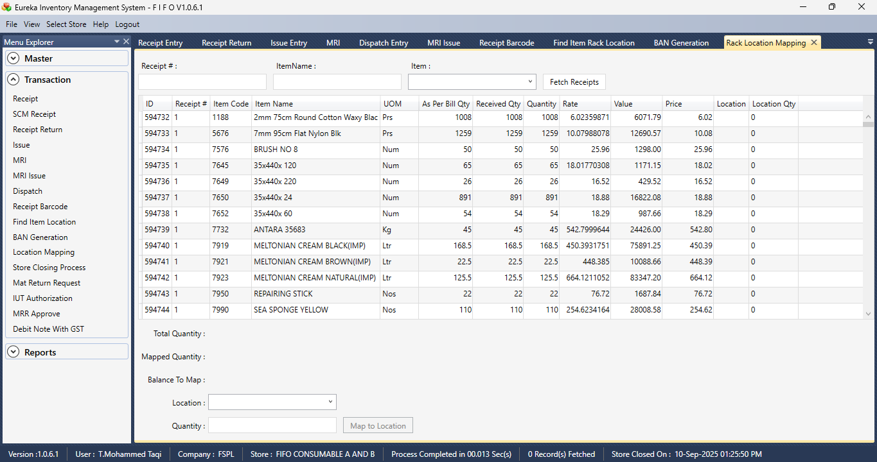

STORE CLOSING PROCESS

Section 1  
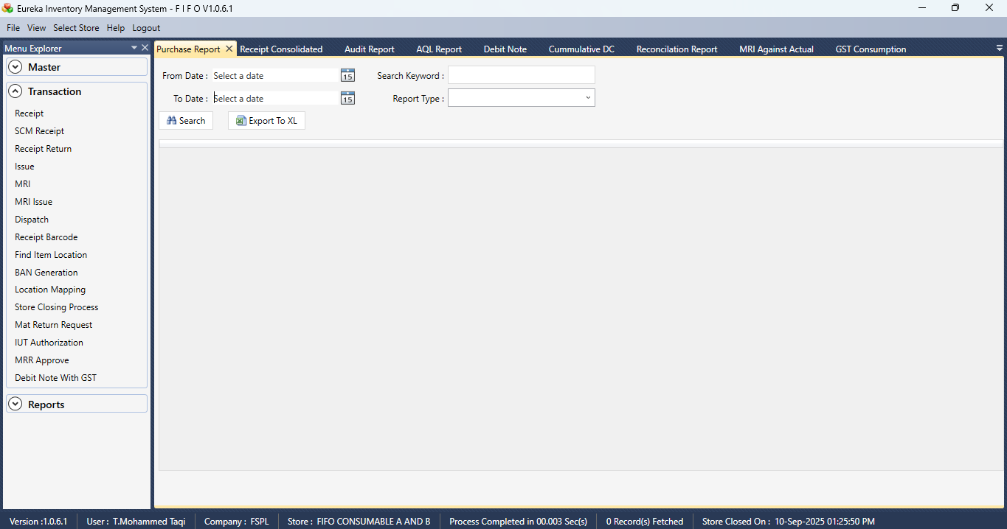

MAT RETURN REQUEST

Section 1

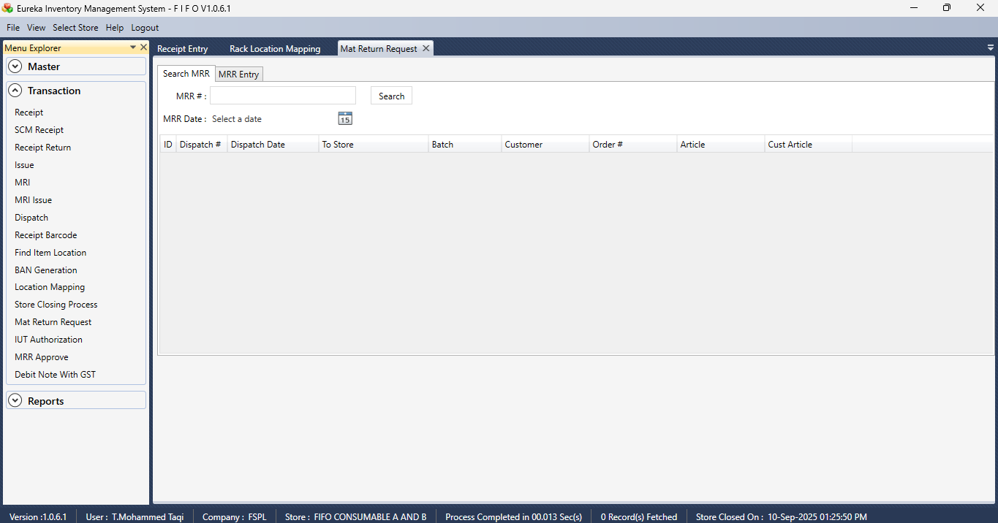

IUT AUTHORIZATION

Section 1   
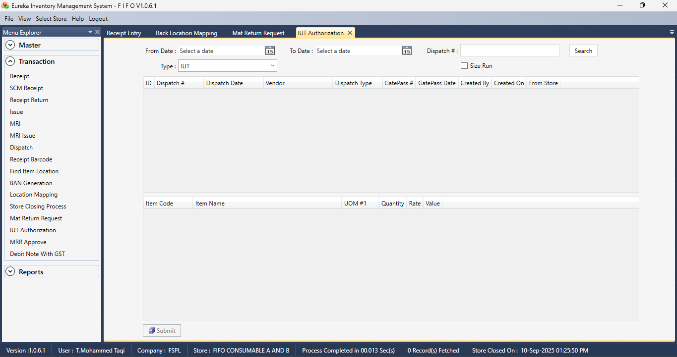

Section 2  
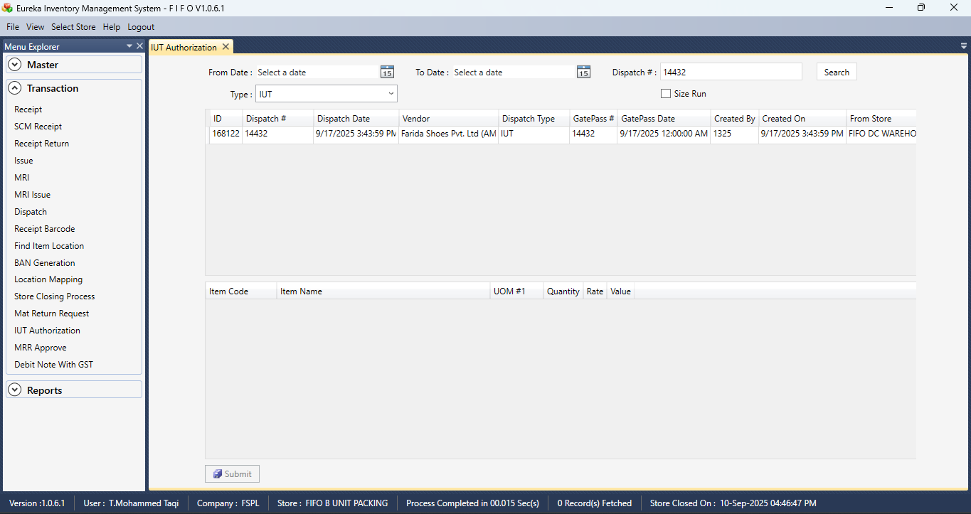

Section 3  
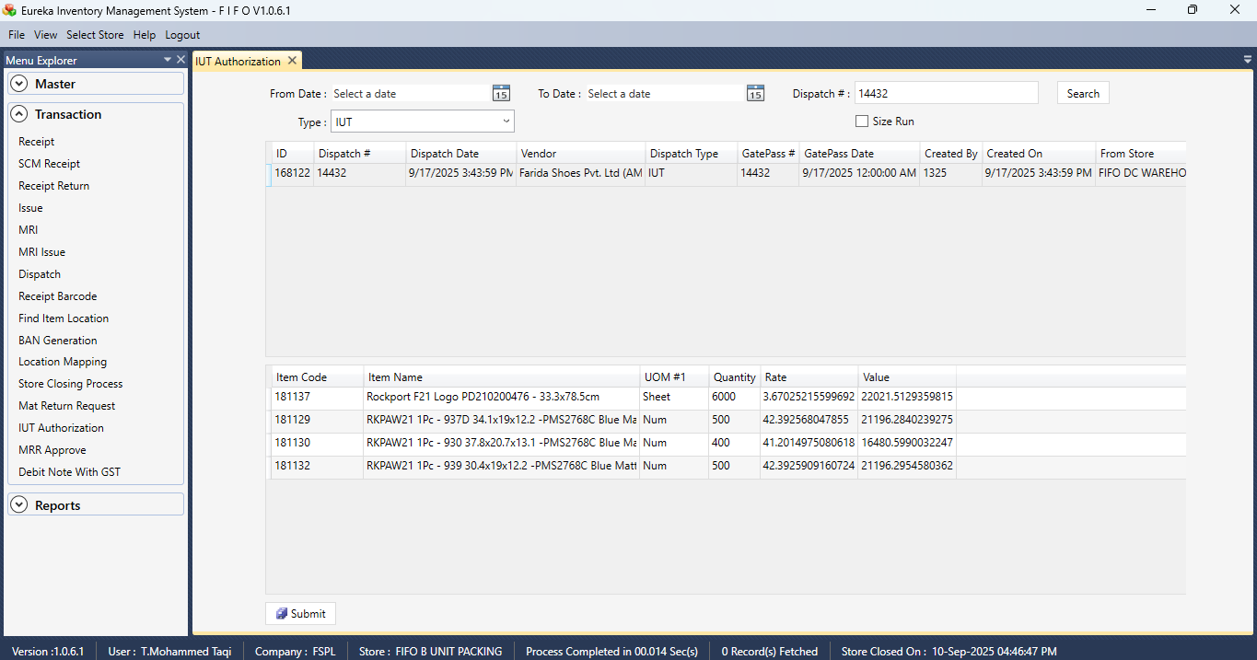

MRP SOURCING APPROVAL

Section 1  
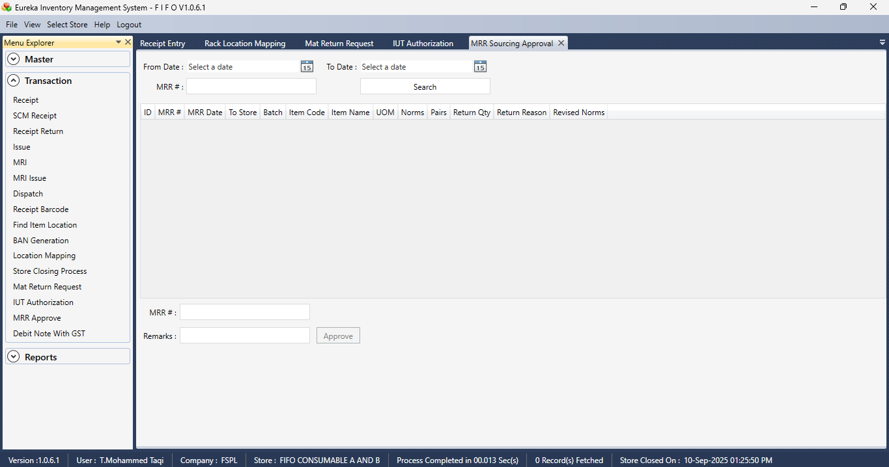

DEBIT NOTE WITH GST

Section 1  
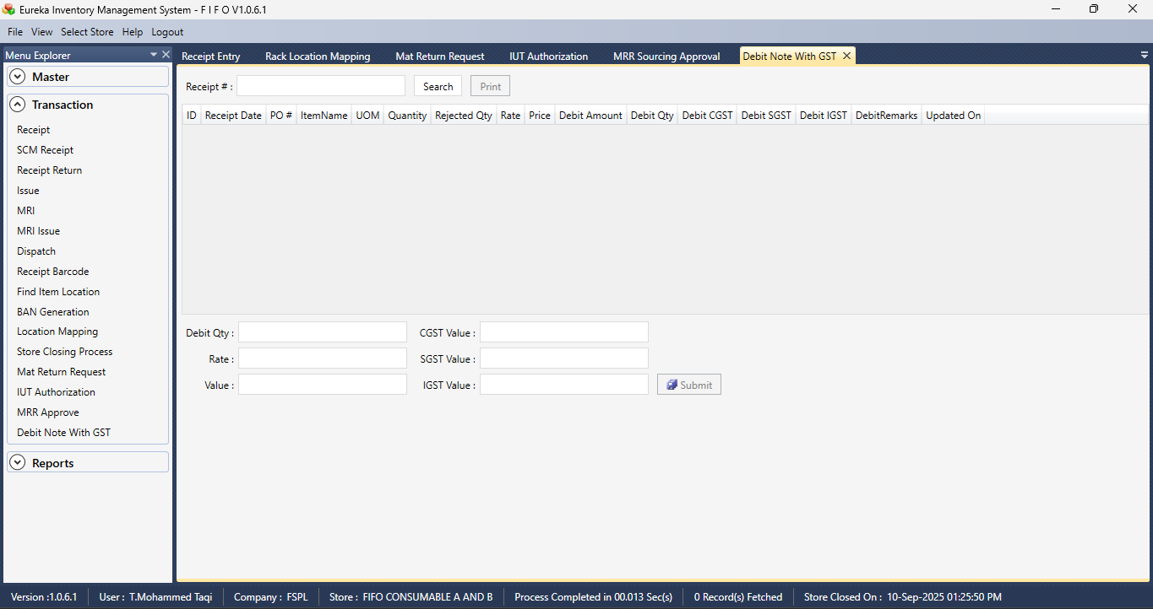

RECIEPT REGISTER

Section 1  
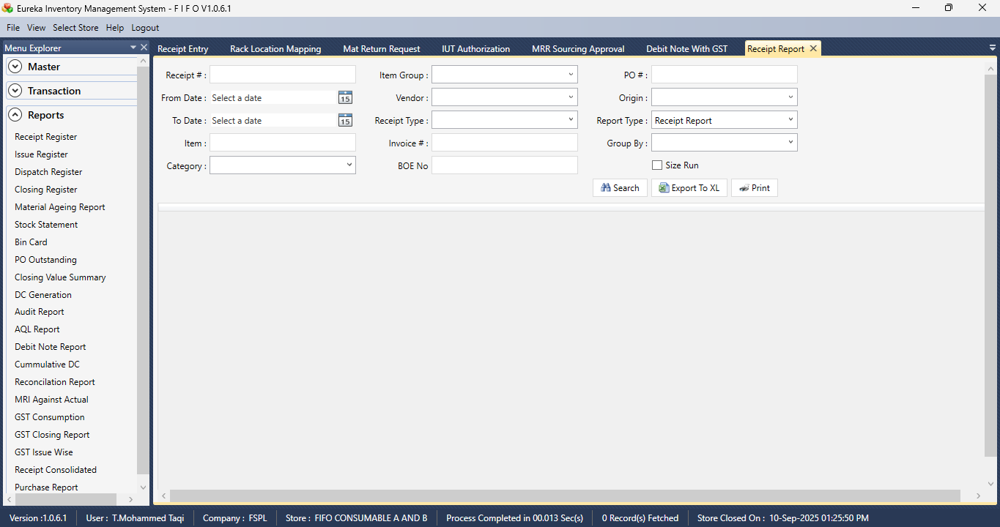

Section 2  
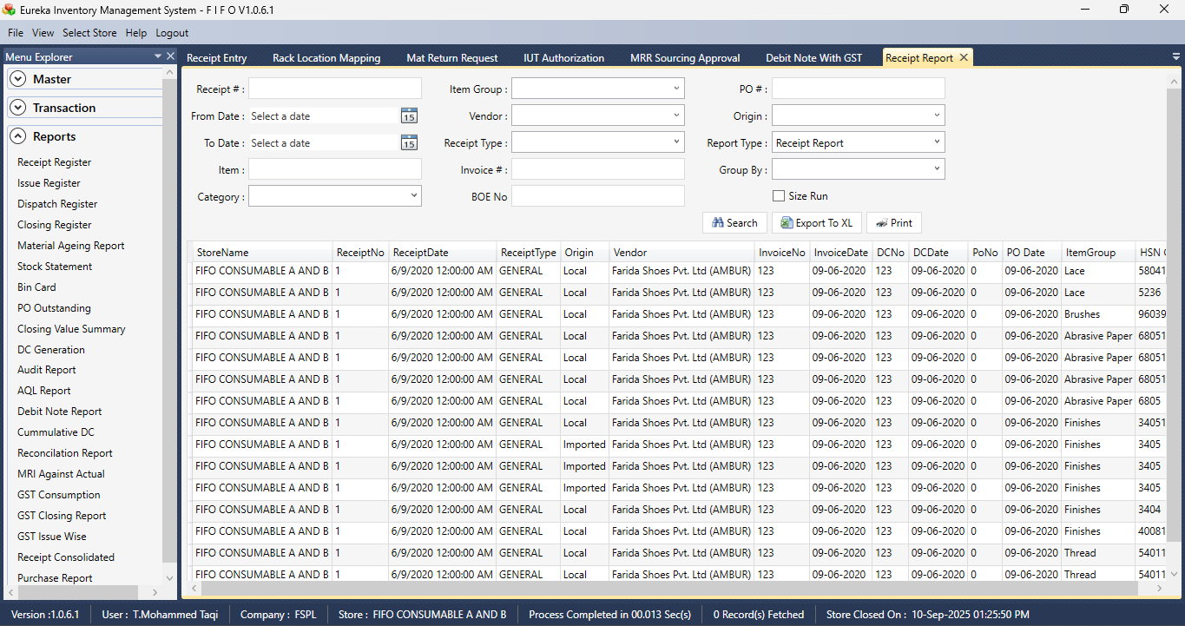

Section 3  
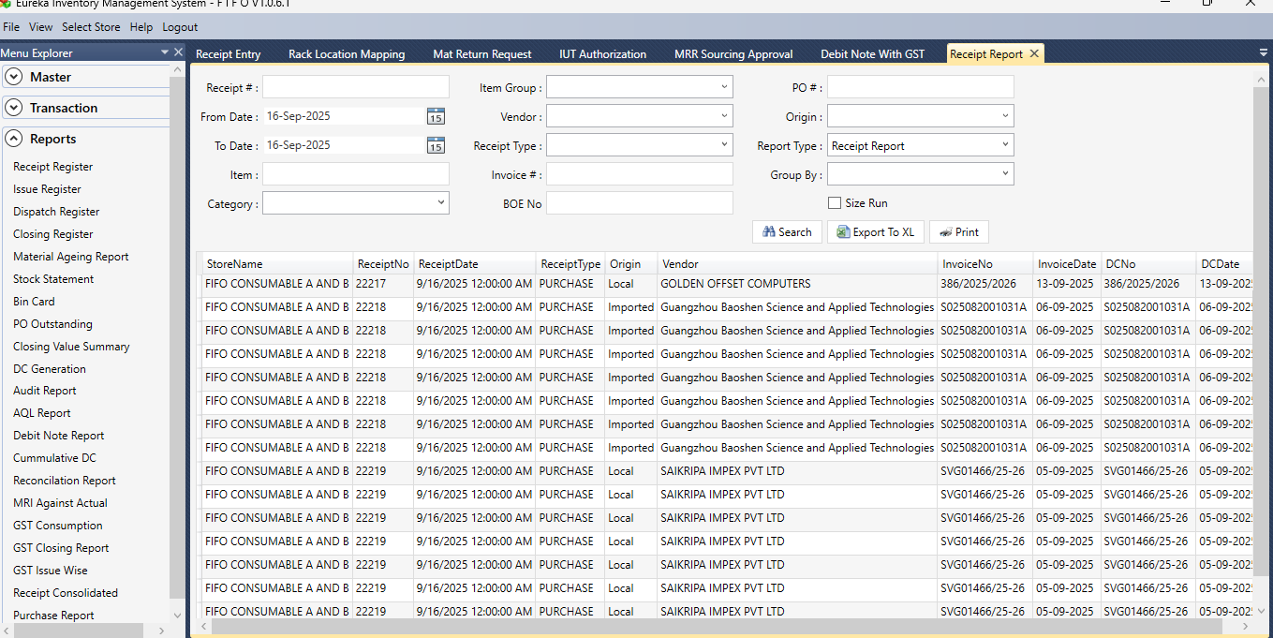

ISSUE REGISTER

Section 1  
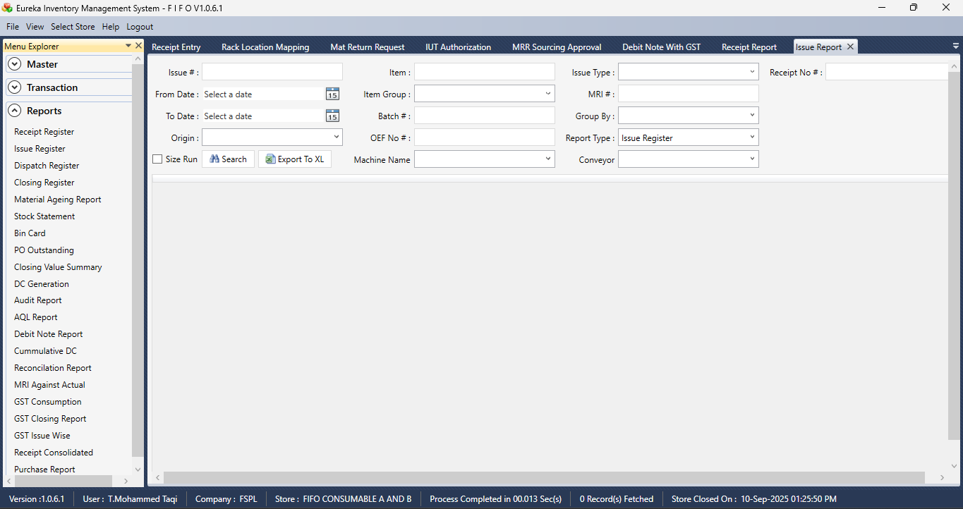

Section 2  
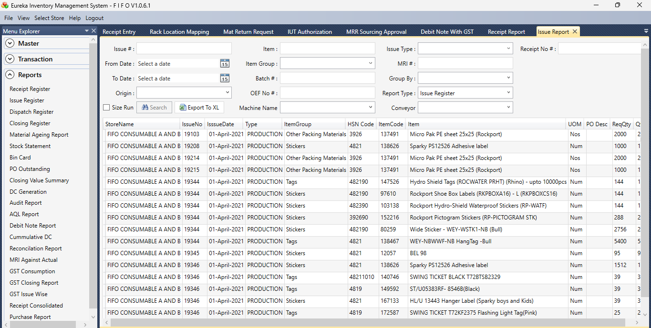

DISPATCH REGISTER  
  
Section 1  
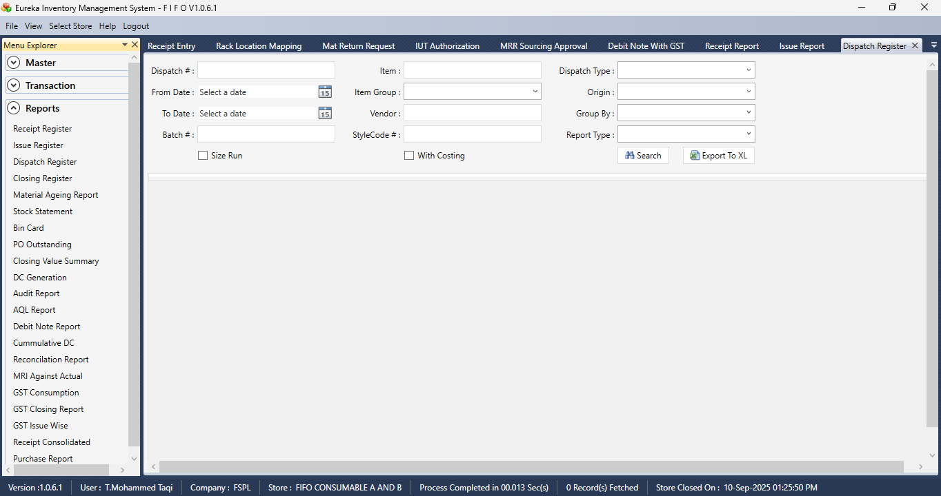

Section 2  
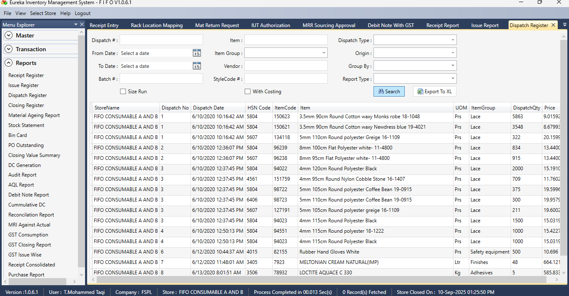

CLOSING REGISTER  
  
Section 1  
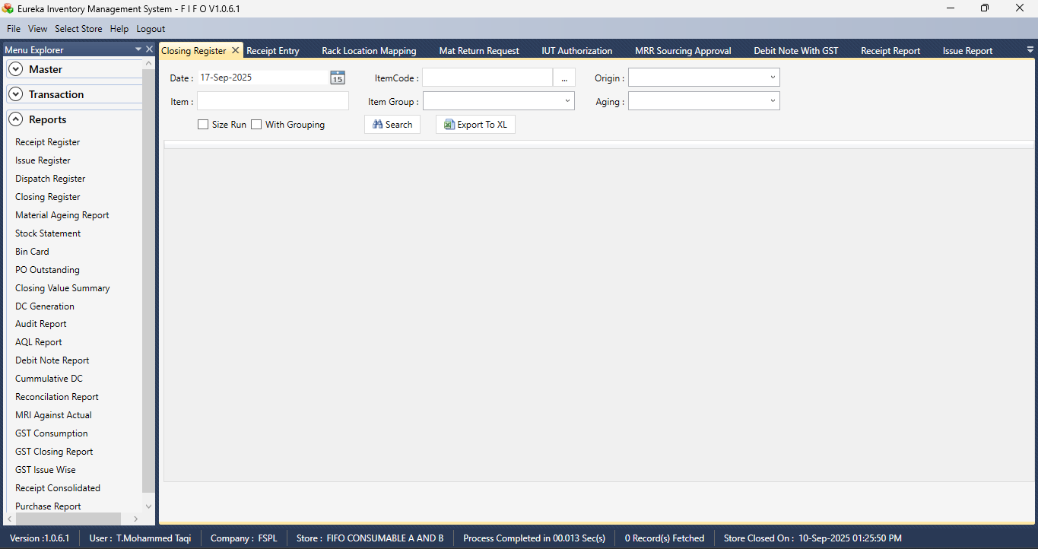

Section 2  
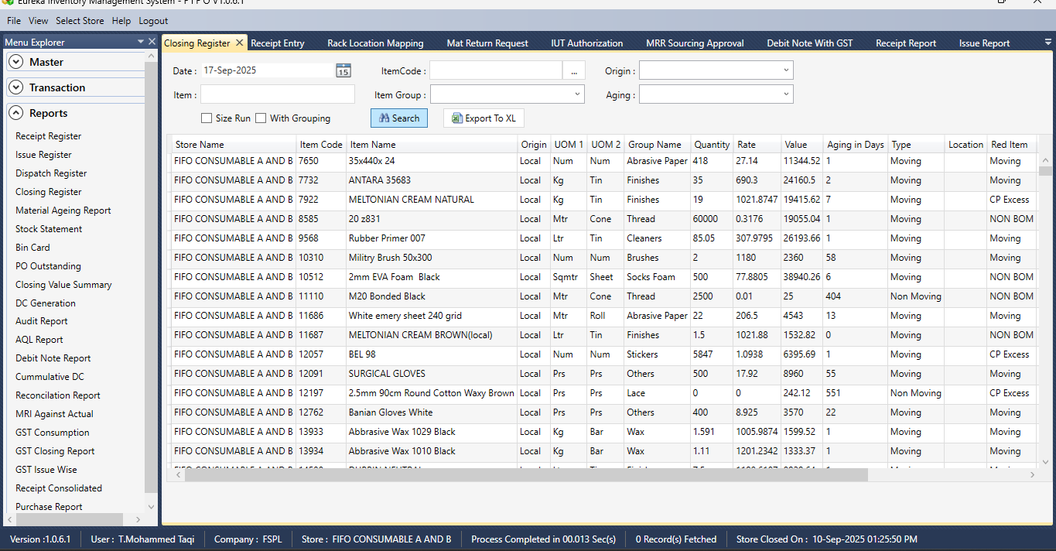

MATERIAL AGEING REPORT

Section 1  
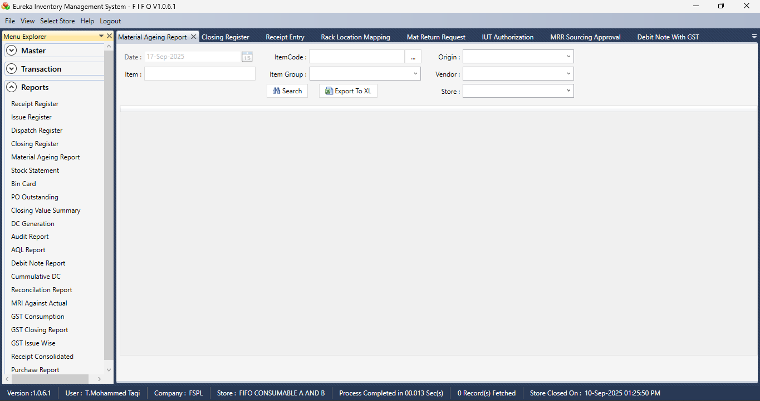

Section 2  
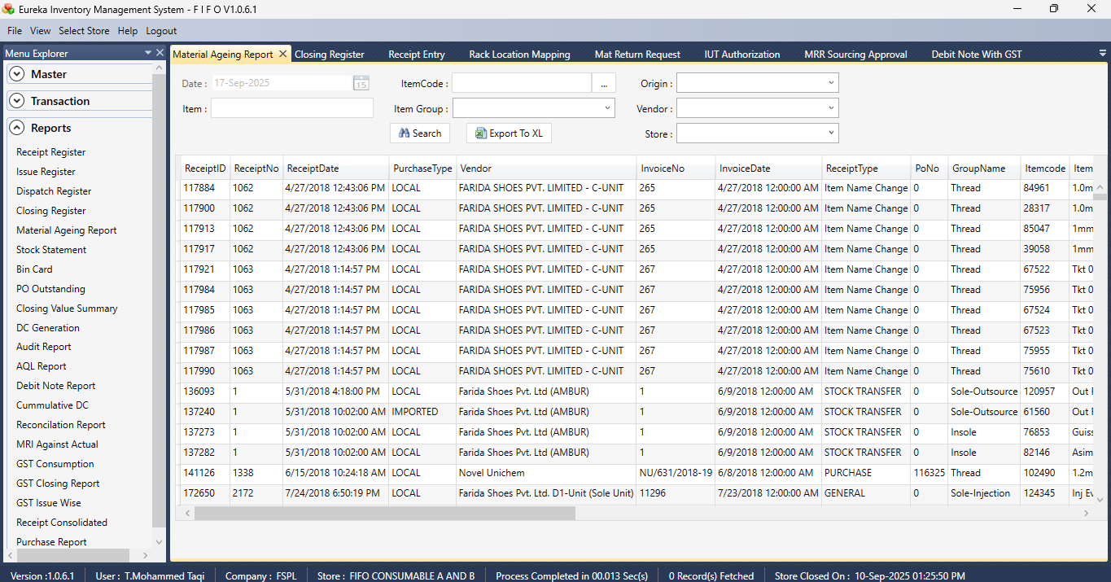

STOCK STATEMENT

Section 1  
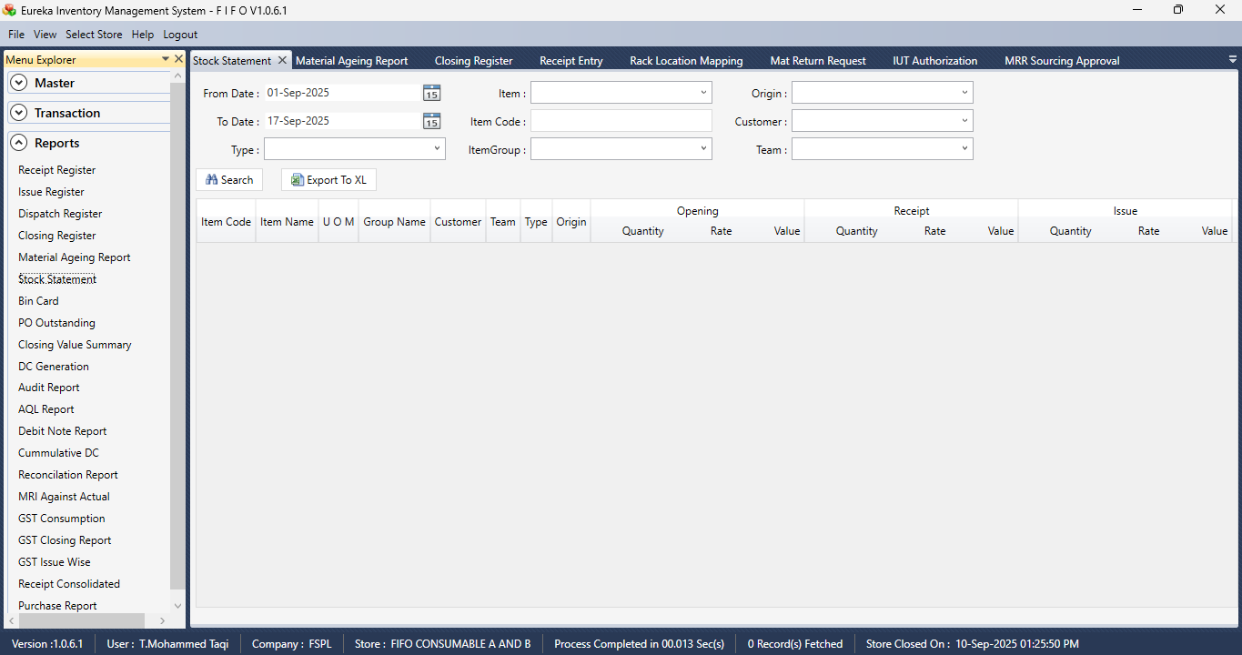

Section 2  
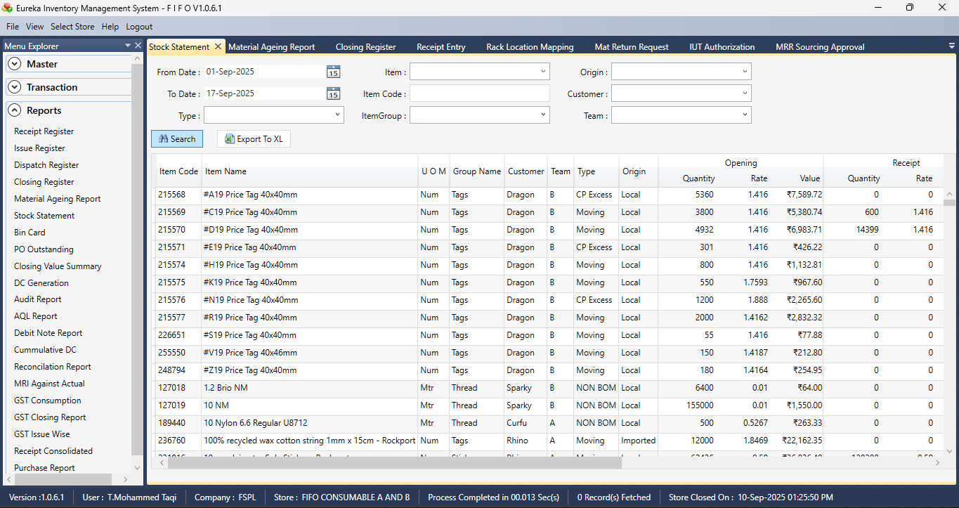

BIN CARD

Section 1  
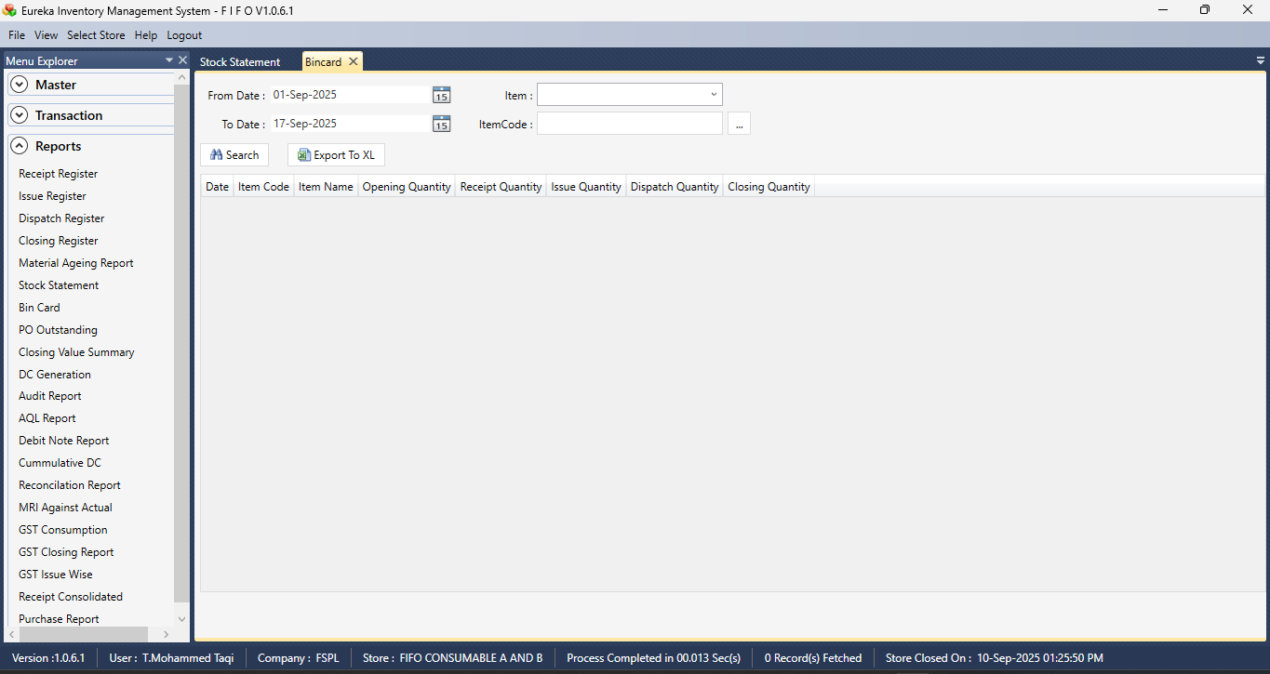

Section 2  
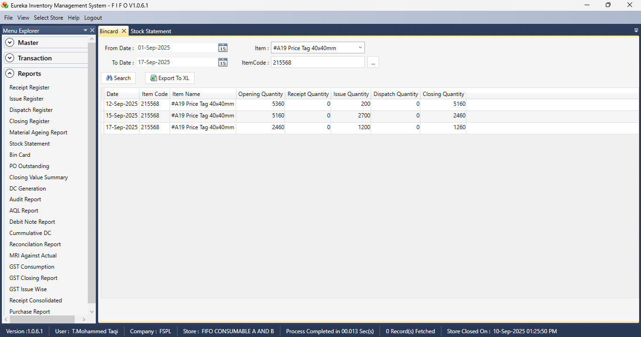

PURCHASE ORDER OUTSTANDING

Section 1  
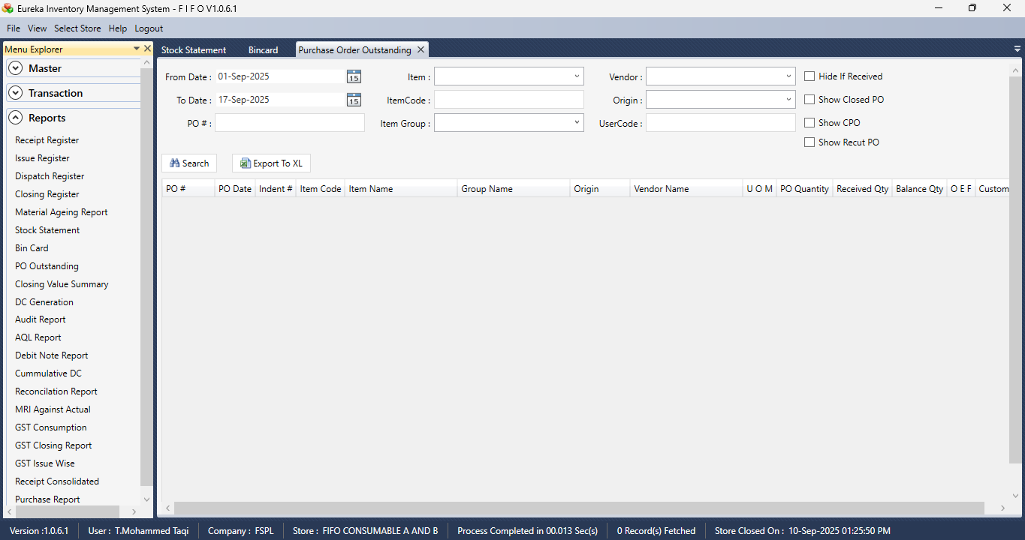

Section 2  
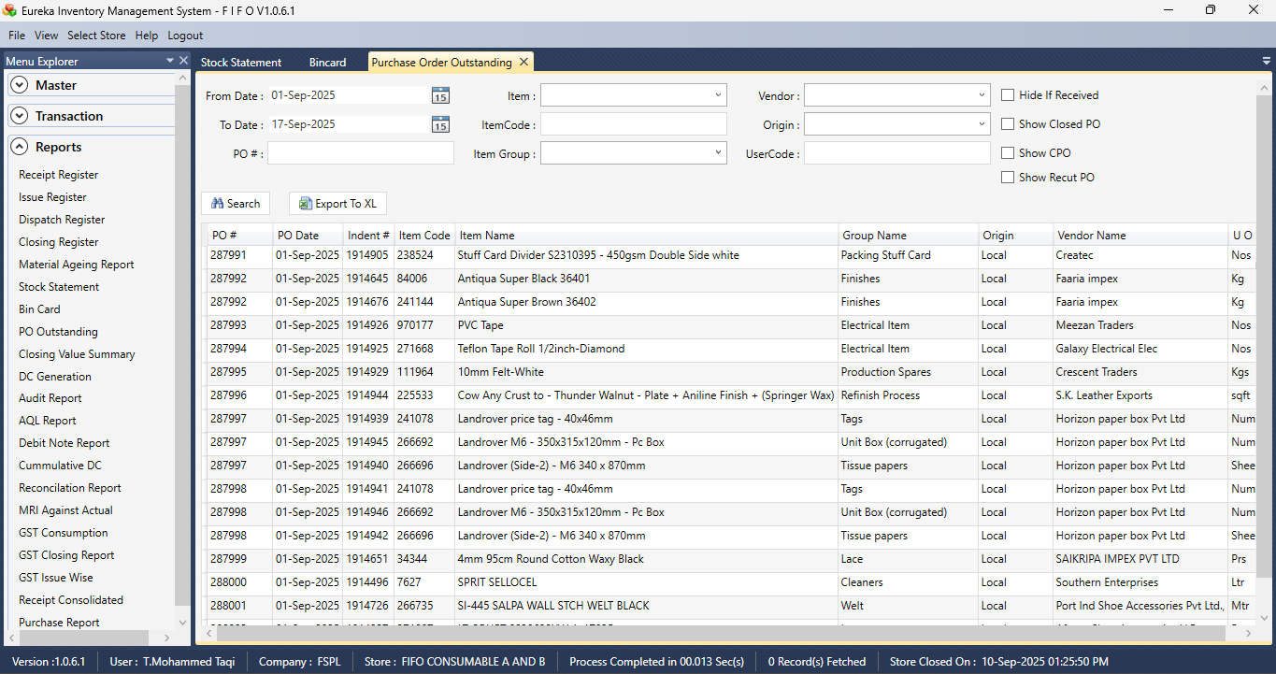

CLOSING VALUE SUMMARY

Section 1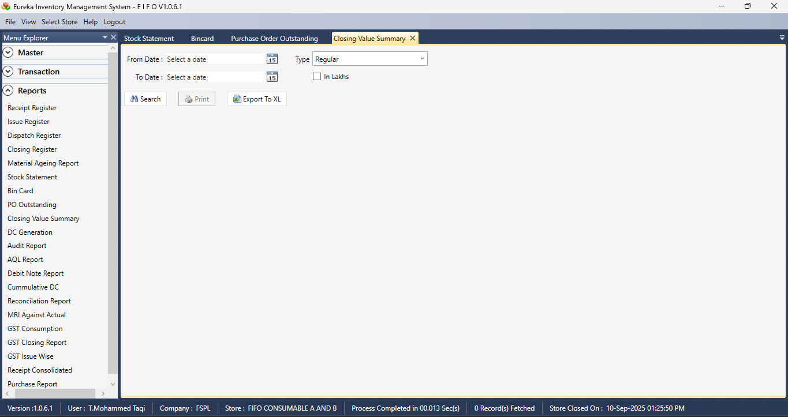

Section 2  
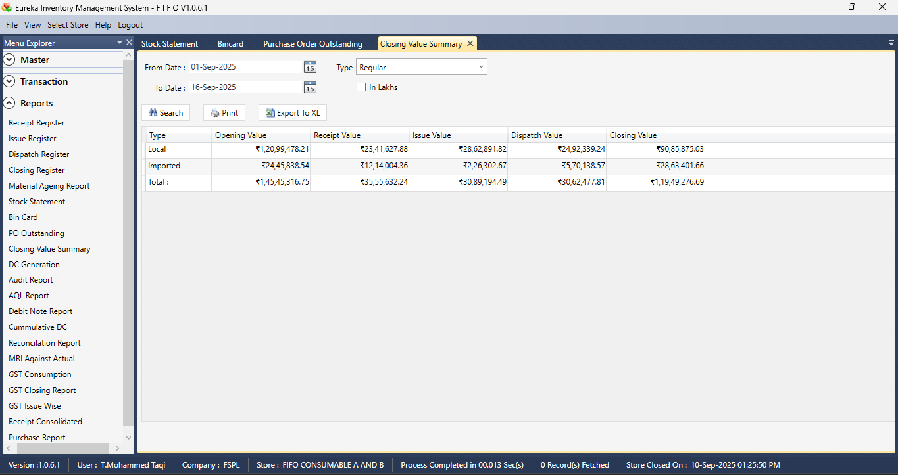

DC GENERATION

Section 1  
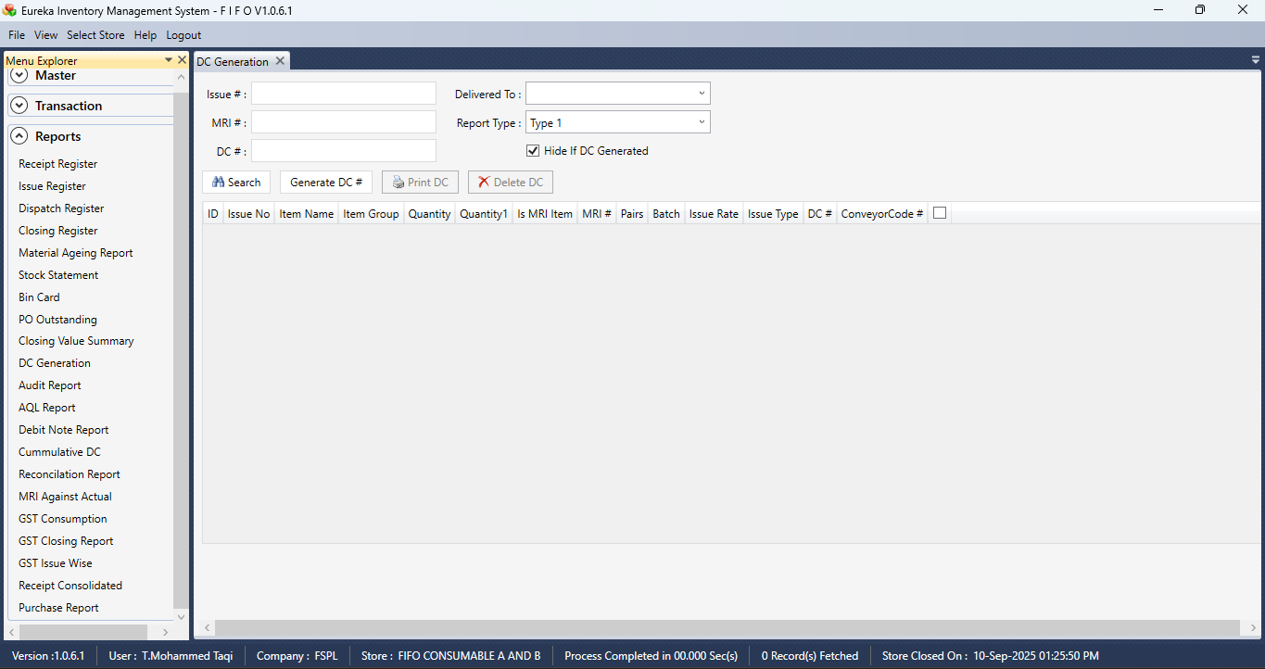

AUDIT REPORT

Section 1  
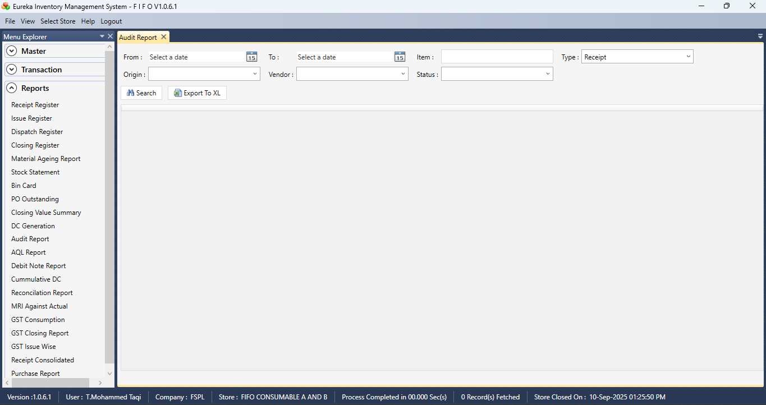

Section 2  
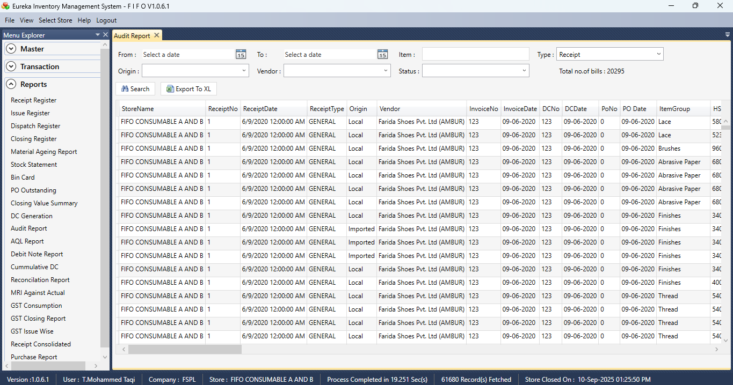

Section 3  
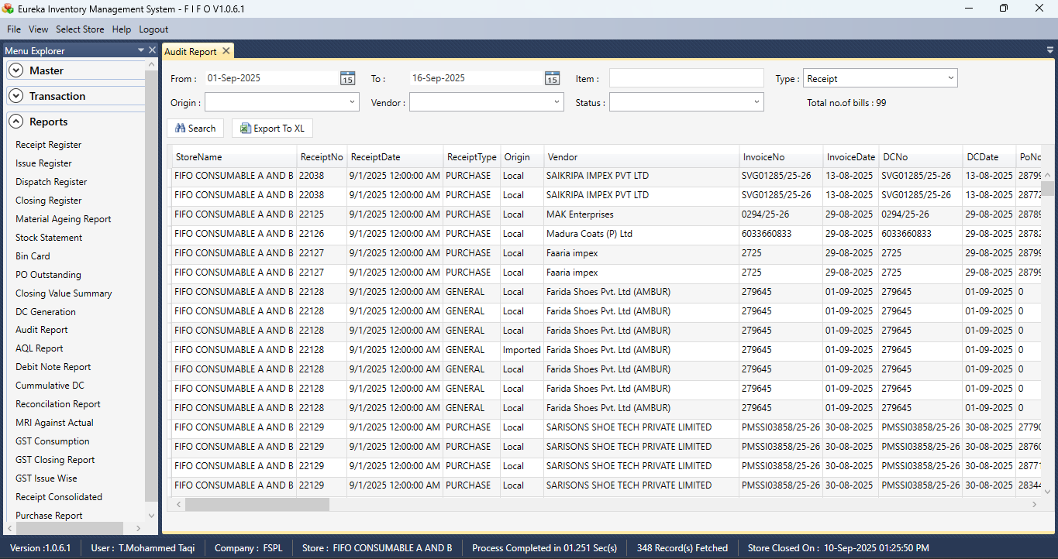  
  
  
Section 4  
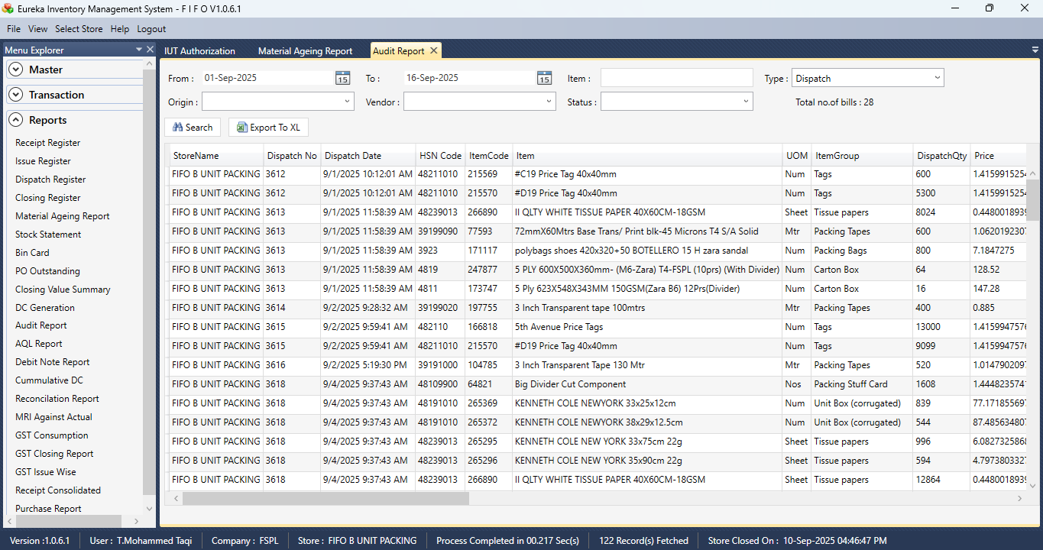

AQL REPORT

Section 1  
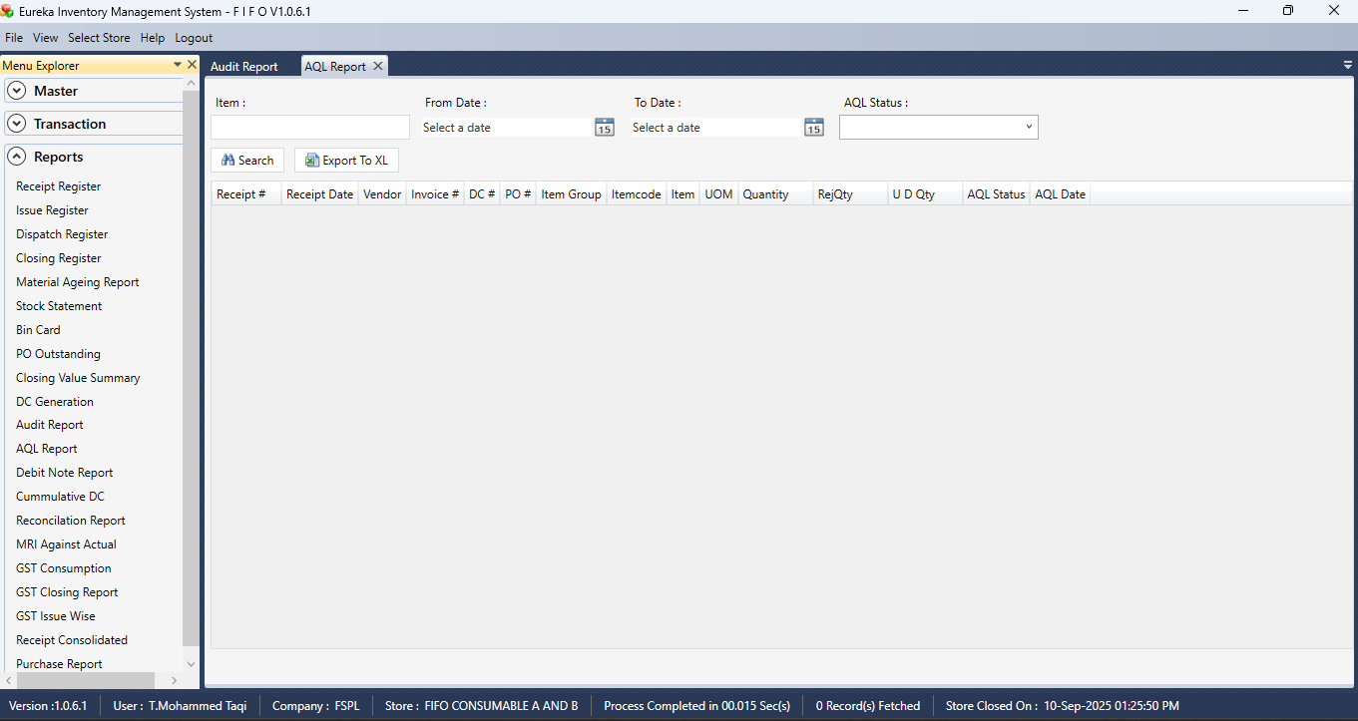

Section 2  
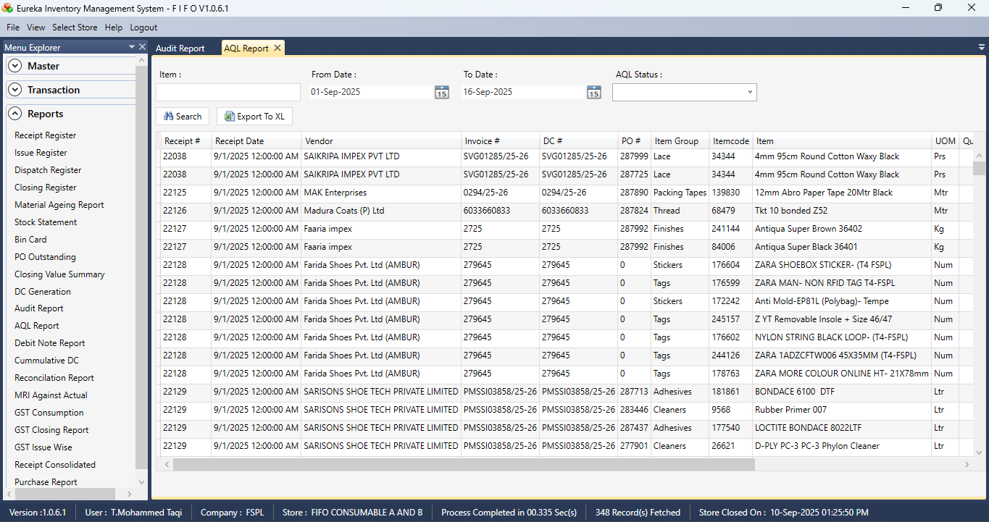

Section 3  
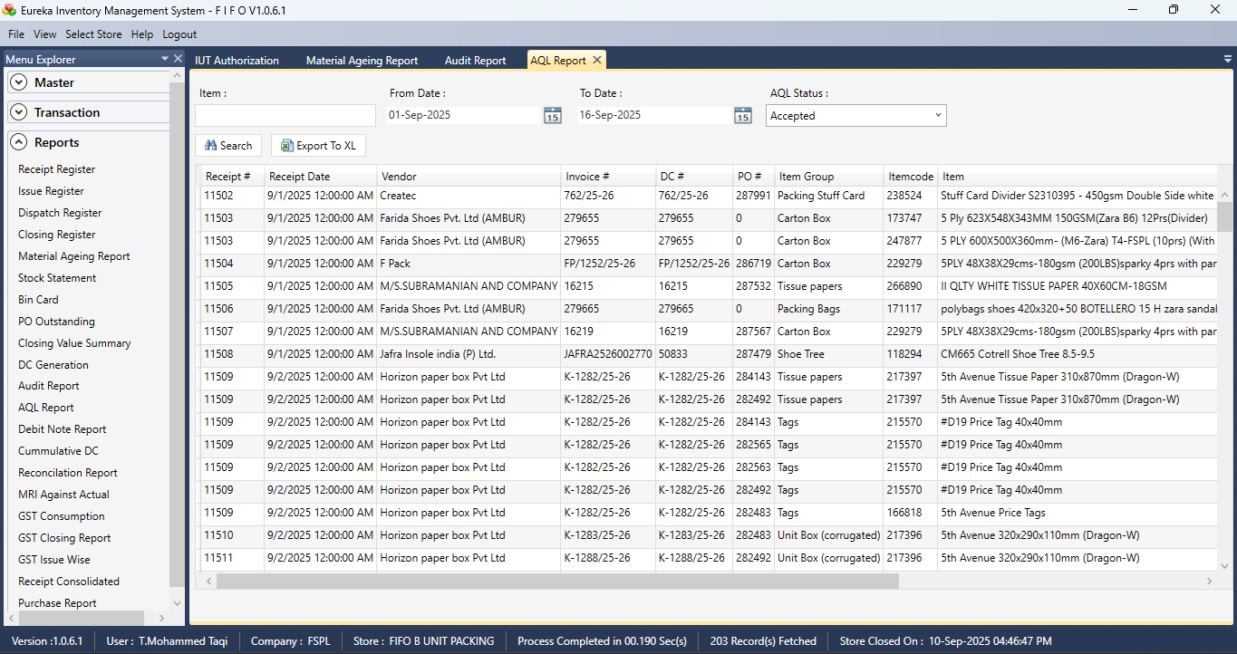

DEBIT NOTE

Section 1  
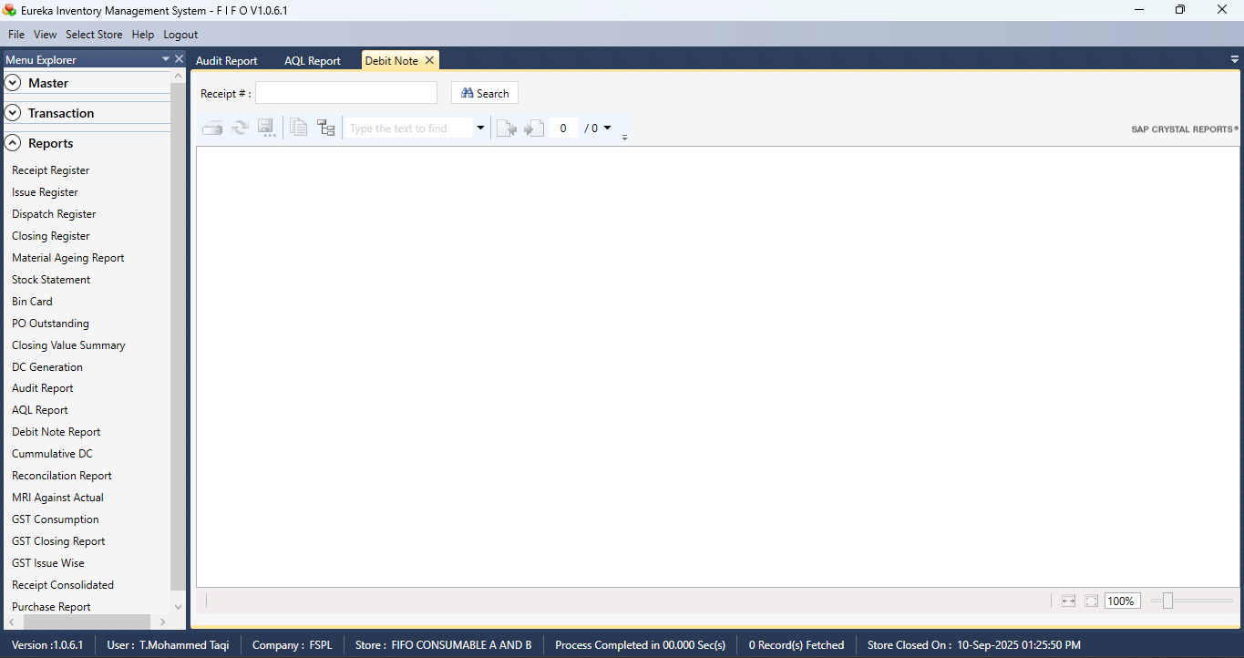

CUMMULATIVE DC

Section 1  
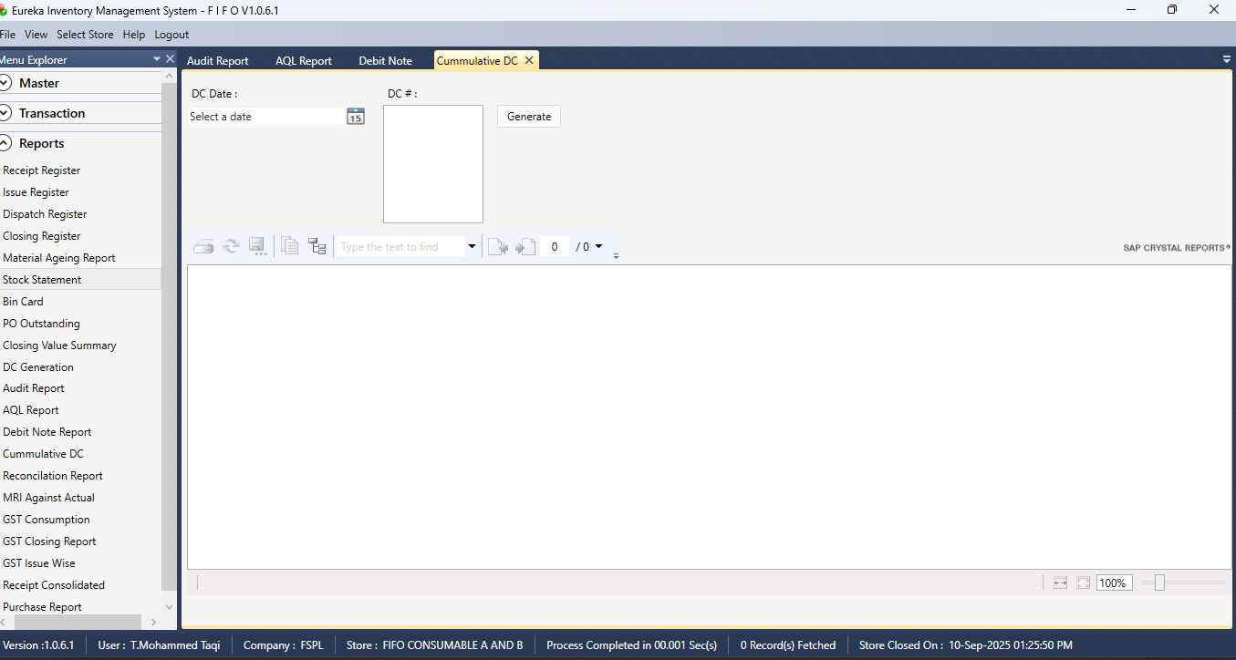

RECONCILATION REPORT

Section 1  
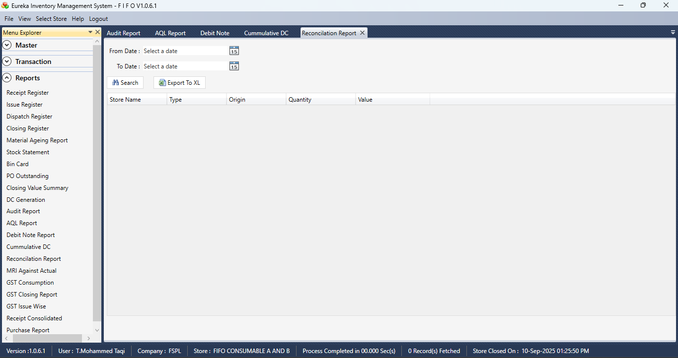

Section 2  
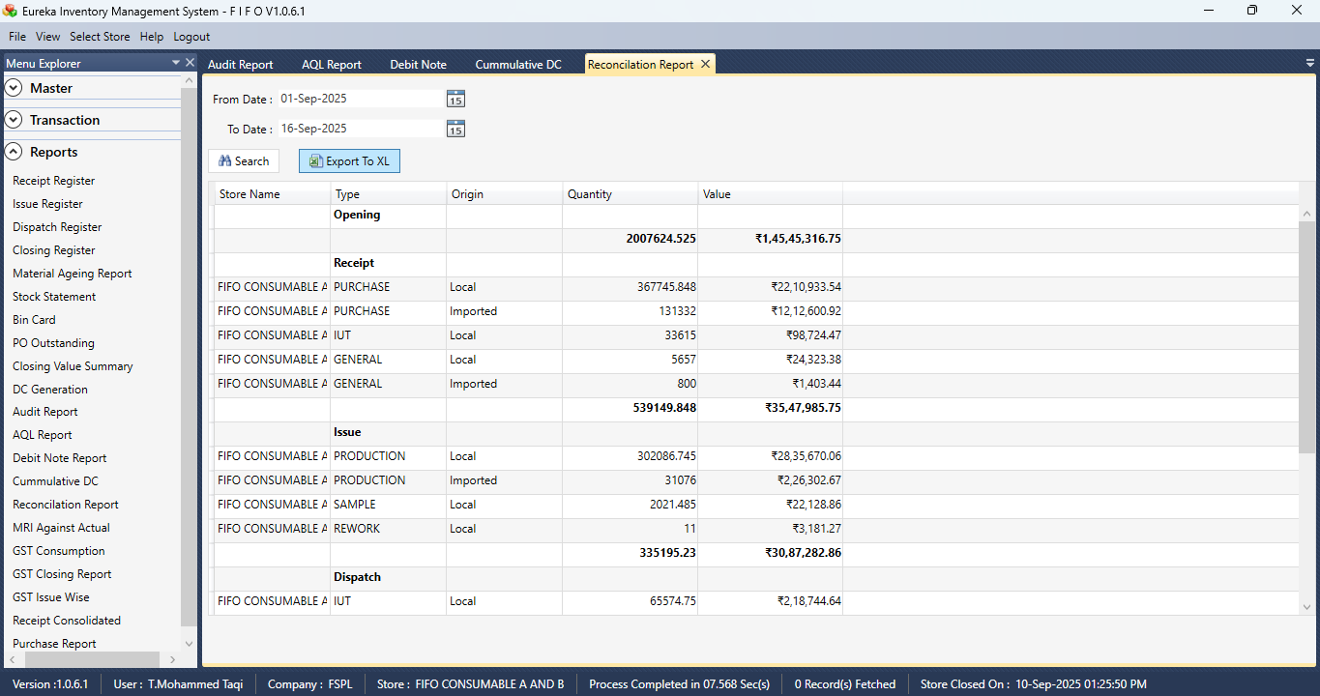

MRI AGAINST ACTUAL

Section 1  
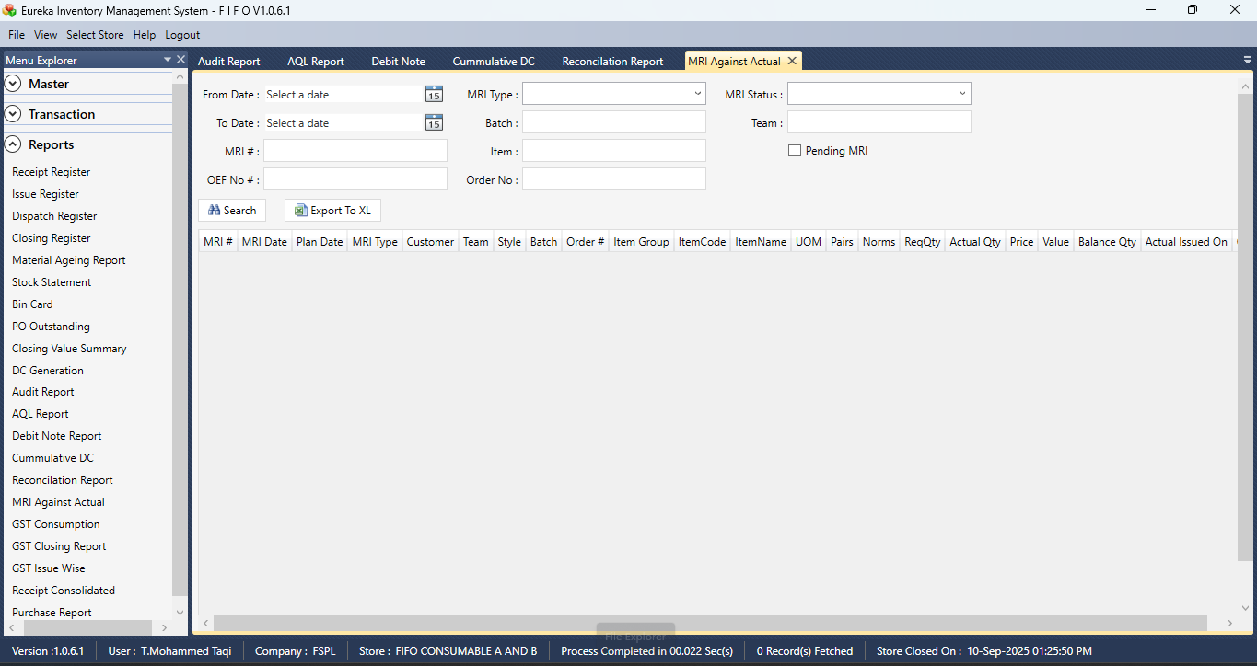

Section 2  
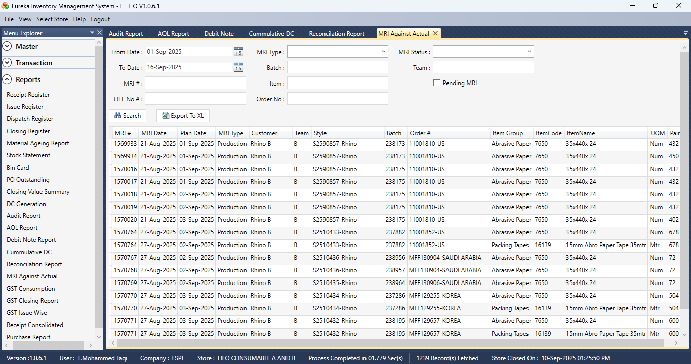

GST CONSUMPTION

Section 1  
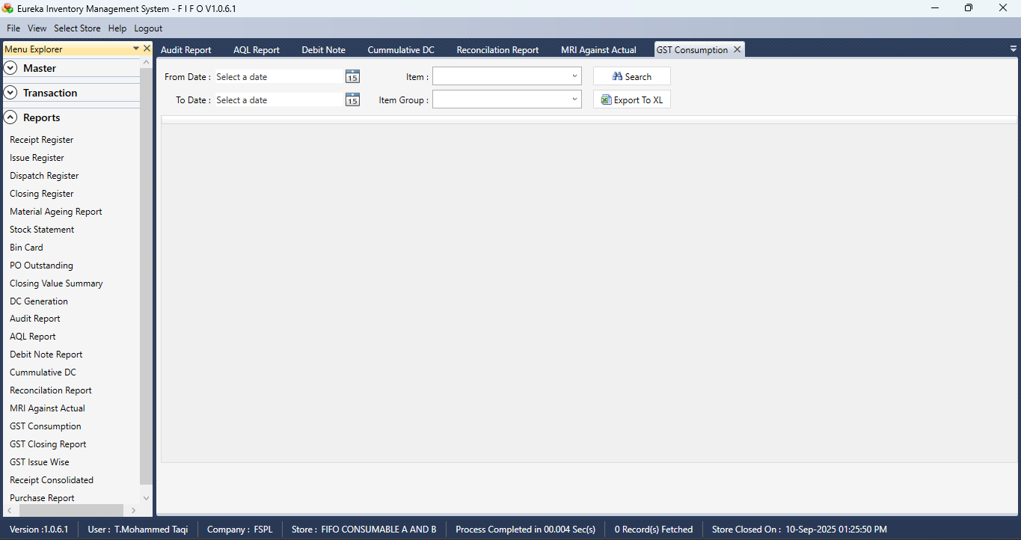

GST CLOSING REPORT

Section 1  
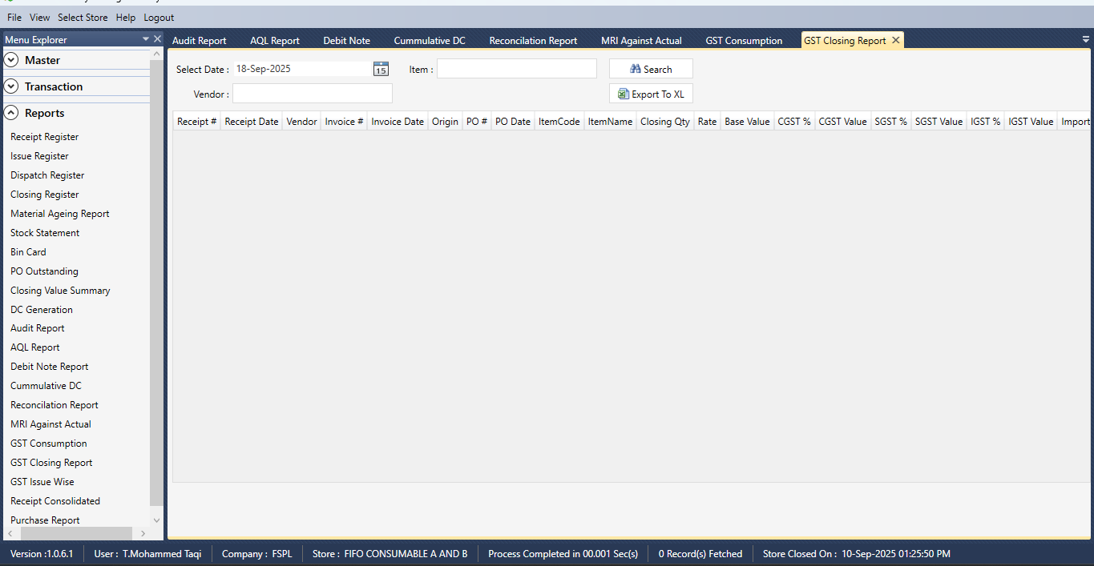

Section 2  
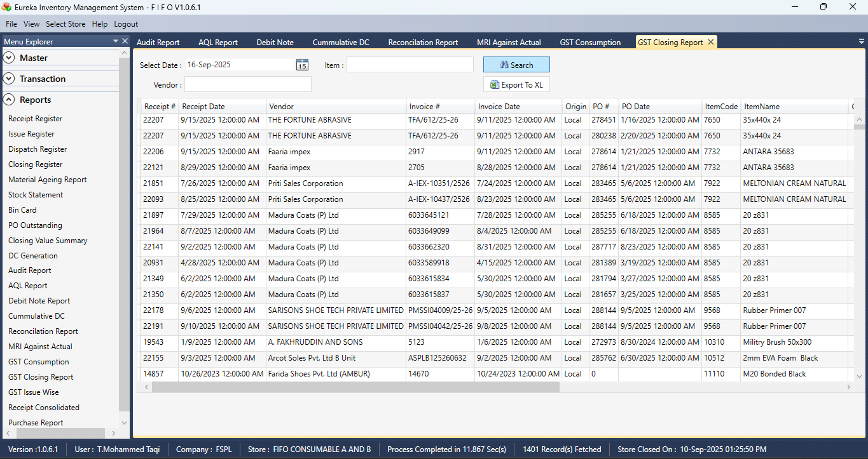

GST ISSUE WISE

Section 1  
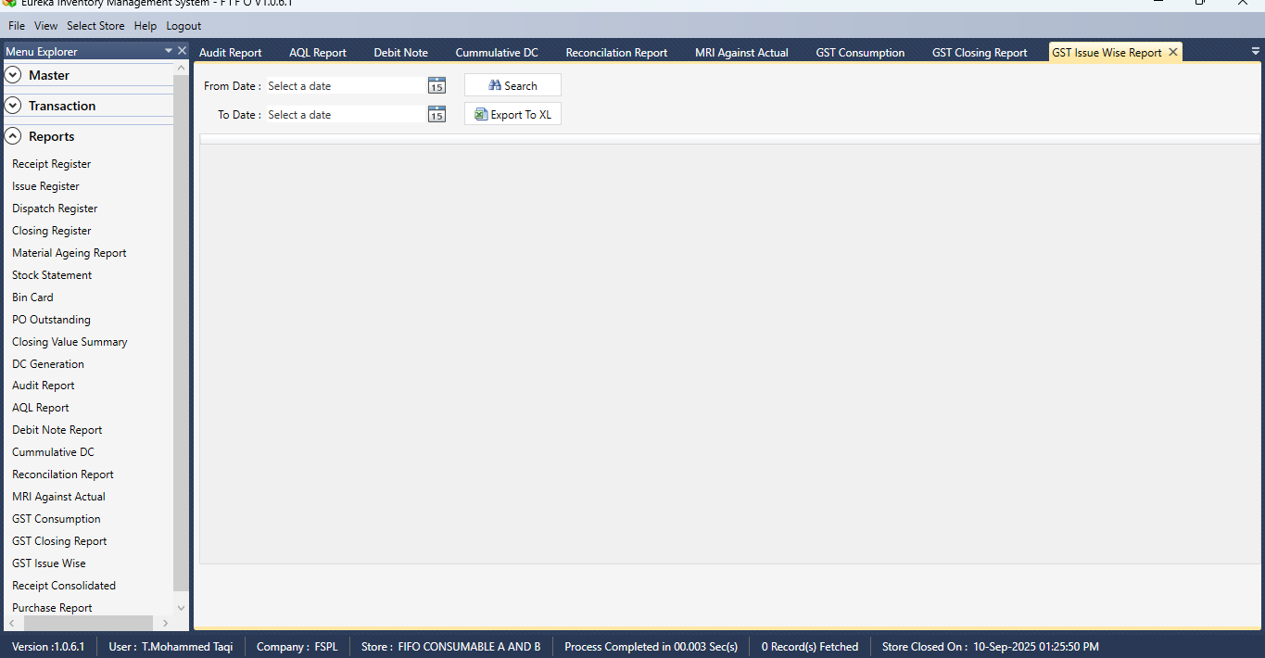

Section 2  
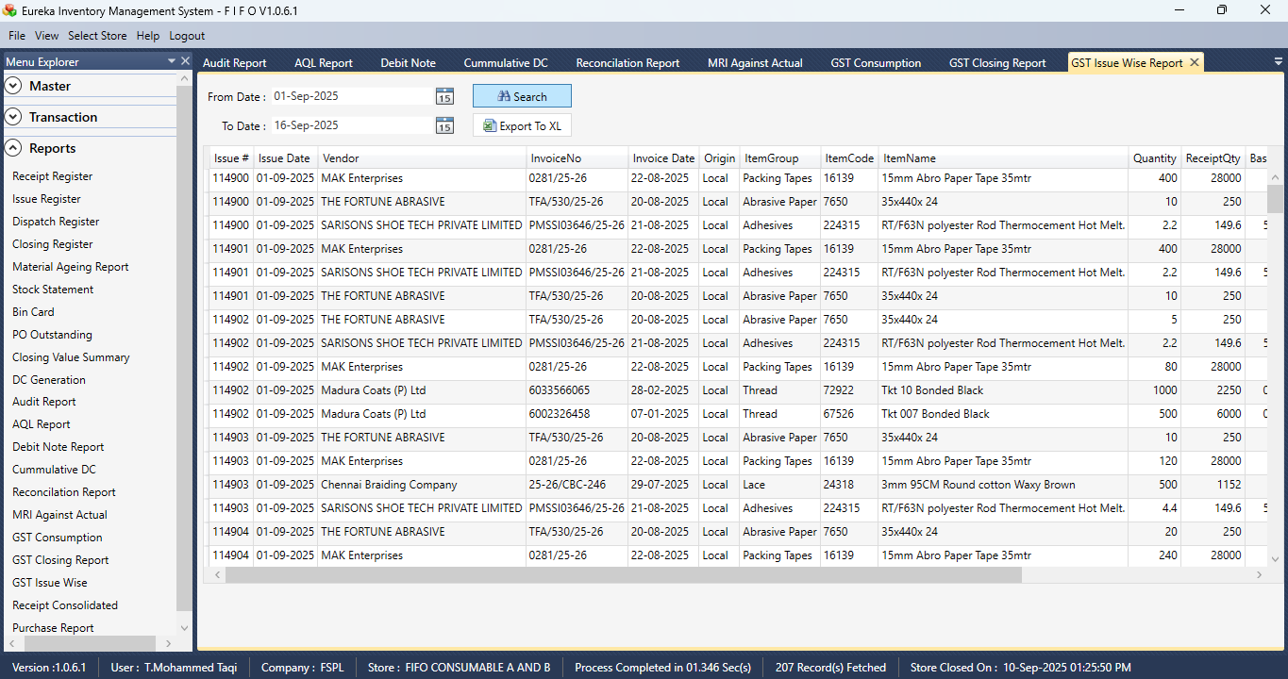

RECEIPT CONSOLIDATED

Section 1  
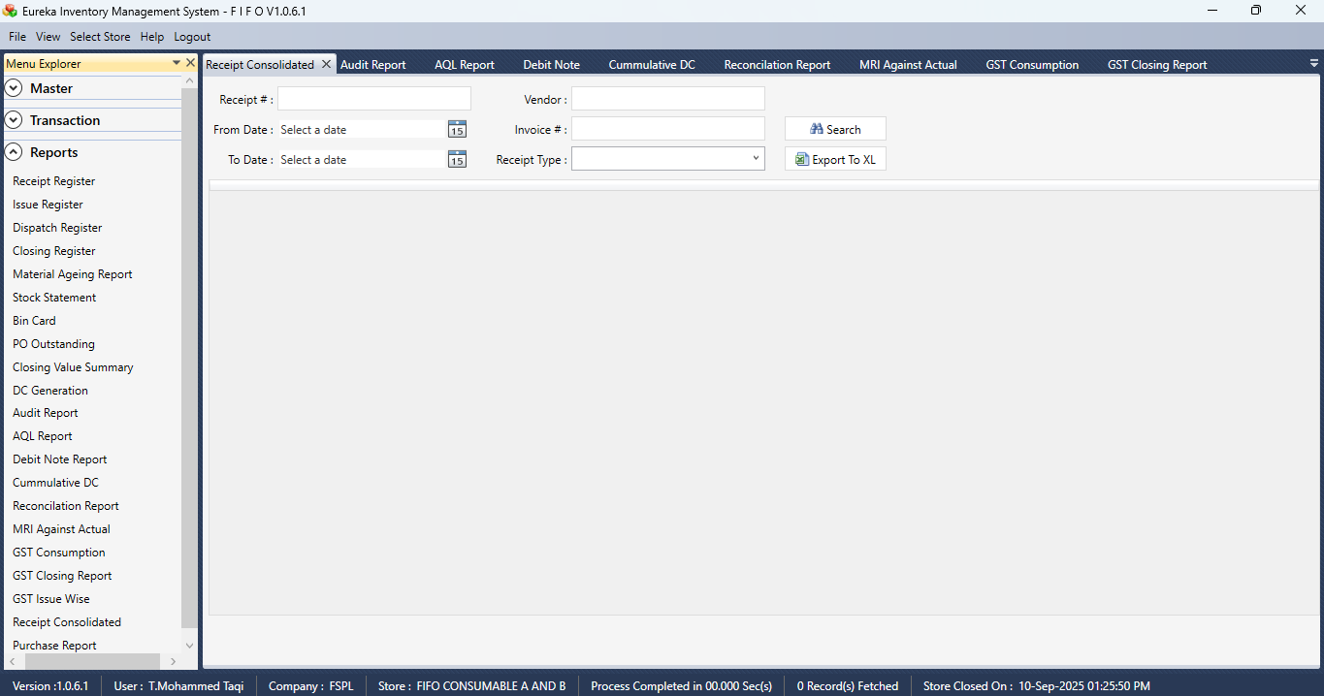

Section 2  
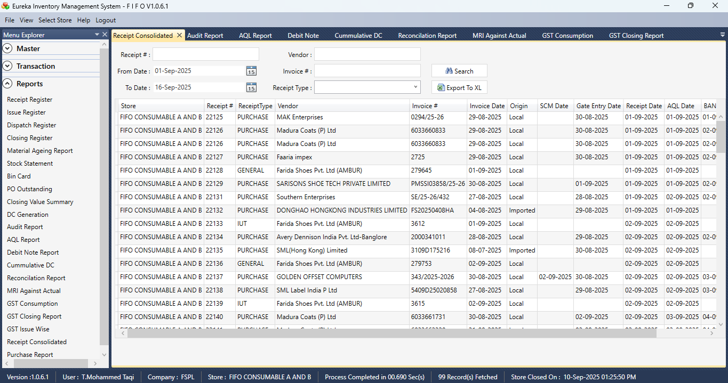

PURCHASE REPORT

Section 1  
